Big Data Knowledge Discovery project launched at SIRCA
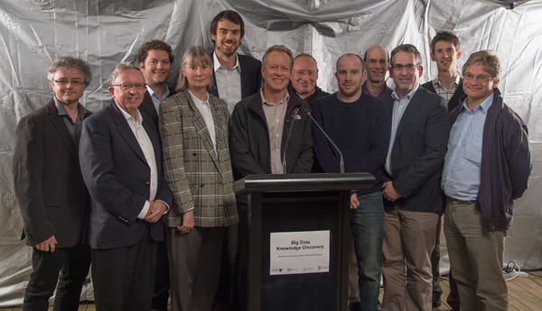
Big Data Knowledge Discovery project members
6 June 2013
The School of Geosciences EarthByte Group teams with NICTA, SIRCA and Macquarie University to unearth ‘big data’ insights for the natural sciences. This $12M, three-year research and innovation project will advance fundamental mathematics and statistics to provide a framework, methodologies and tools for data-enabled scientific insight and discovery. It is supported by $4M from the Science and Industry Endowment Fund (SIEF) and $8M from the research collaborators over the life of a three-year research project. It will combine NICTA’s world-class machine learning capabilities and SIRCA’s expertise in big data software engineering with three of Australia’s three domains leaders in natural science from Macquarie University and the University of Sydney:
- Geosciences and Earth dynamics and tectonics led by Professor Dietmar Muller
- Terrestrial Ecology led by Professor Mark Westoby at Macquarie University
- Physics and Mathematics of Complex Laser Systems led by Professor Deb Kane at Macquarie University
How do we distinguish underlying trends in datasets from random variations - or ‘noise’ - and extract the meaningful information? Can we find out what Australia looked like 1.5 billion years ago when it consisted of 5 continents surrounded by rings of fire generating some of the world’s richest metal deposits? These are the sorts of questions the project will address, drawing on the skills of a multi-disciplinary team from NICTA, SIRCA, Macquarie University and The University of Sydney. NICTA is Australia’s Information and Communications Technology Research Centre of Excellence and SIRCA’s technology is used by over 400 leading institutions in the financial services industry worldwide. SIRCA technology, in partnership with Thompson Reuters, powers the largest and most comprehensive research database of historic financial markets data in the world.
The essence of the Big Data Knowledge Discovery project is to bring some of brightest people in the world in computer science from NICTA (in machine learning and analytics) and SIRCA (in software and big data) together with three of Australia's most distinguished natural scientists in physics, plant science and geosciences to tackle grand scientific challenges in completely new ways. “Working together we plan on developing a new space-time data mining approach, exploiting similarities with other research fields such as finance and taking a new look at huge geo-data sets to unravel the structure and evolution of Australia in a global context,” Professor Muller said. His team has previously had success in applying big data mining for earthquake hazard mapping and opal exploration.
“If this project succeeds in its admirably ambitious aims, Australia could one day be home to a new generation of big data analytics tools that could be used by all manner of scientists around the world to advance knowledge discovery around the world,” said Ian Chubb, Chief Scientist of Australia.
“Motivated by the grand challenges of big data, this initiative brings together world leading experts in finance and geoscience - possibly for the first time. SIRCA is very excited by this ground breaking opportunity for two such diverse disciplines to work collaboratively towards a common goal." Said Dr. Michael Briers, CEO, SIRCA.
“We imagine this project will provide a new and powerful platform for data intensive science – not just in the domains we’re talking about tonight, but to many others such as in medical sciences and nutrition,’ said Professor Hugh Durrant-Whyte, CEO, NICTA.

