GPlates Shapefile Tutorial


This section of the tutorial describes some common tasks related to shapefiles that can be carried out in GPlates. The vast majority of users that deal with geospatial data are likely to be using commercial GIS packages to display and edit their data. This tutorial will help you create and prepare data in ArcGIS (a common commercial GIS package) for viewing in GPlates.
It is important to note that GPlates will import any shapefile (assuming it is conforms to shapefile standards), and also export shapefiles to be used in other GIS platforms. That is, shapefiles can be viewed natively in GPlates without having to perform any file conversions. The added benefit of using GPlates is that it is now capable of converting old PLATES4-formatted files into GPlates GPML or shapefile format, and vice versa.
The tutorial will involve loading GPlates data into ArcGIS to familiarize the user on the file conversion capabilities of GPlates. The later sections deal with adding GPlates attributes such as Plate IDs to selected geological provinces in ArcMap, and then reconstructing these features using the EarthByte rotation model.

Note: The shapefiles associated with this tutorial are in a WGS 84 geographic datum. If you are working in another projection within ArcGIS, you may need to apply a geographic transformation to the data. This is reasonably straight-forward and automatic in most GIS packages. Refer to the manual of your GIS package for more information.

Required data:
- GPlates data bundle (i.e. DataBundleForNovice folder)
- Shapefile tutorial data (i.e. GPlates_SHP_Tutorial folder)

Exporting GPlates files to shapefiles for use in GIS packages such as ArcGIS
- Open GPlates
- The sample GPlates data is contained in a folder called ‘DataBundleForNovice’.
In GPlates, navigate to File → Manage Feature Collections → Open File…
- Navigate to the sample data directory, and select the coastline file.
i.e. “Global_EarthByte_GPlates_Coastlines_20091014.dat”
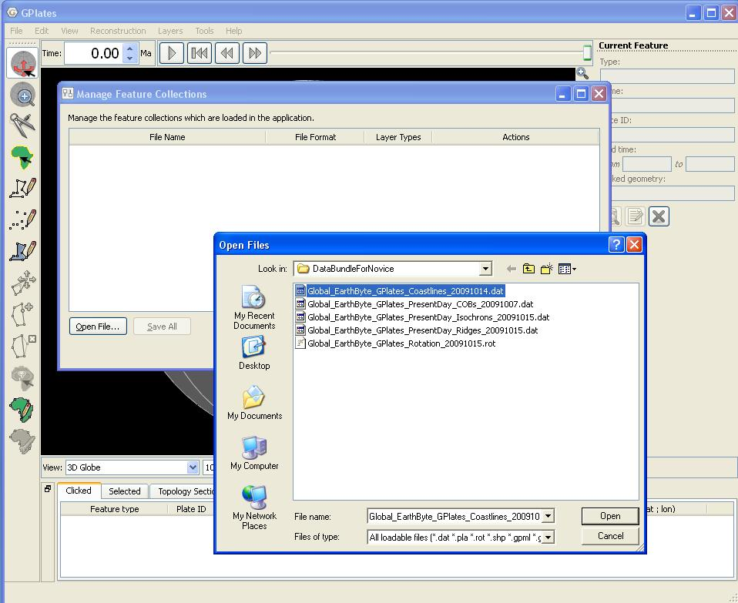
- Click ‘Open’ to load and display the file in GPlates.
- The coastline is now displayed in GPlates. To export this as a shapefile, open the ‘Manage Features Collection’ window again. Next to the filename, click the ‘Save a copy of the file with a different name’ 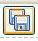 button.
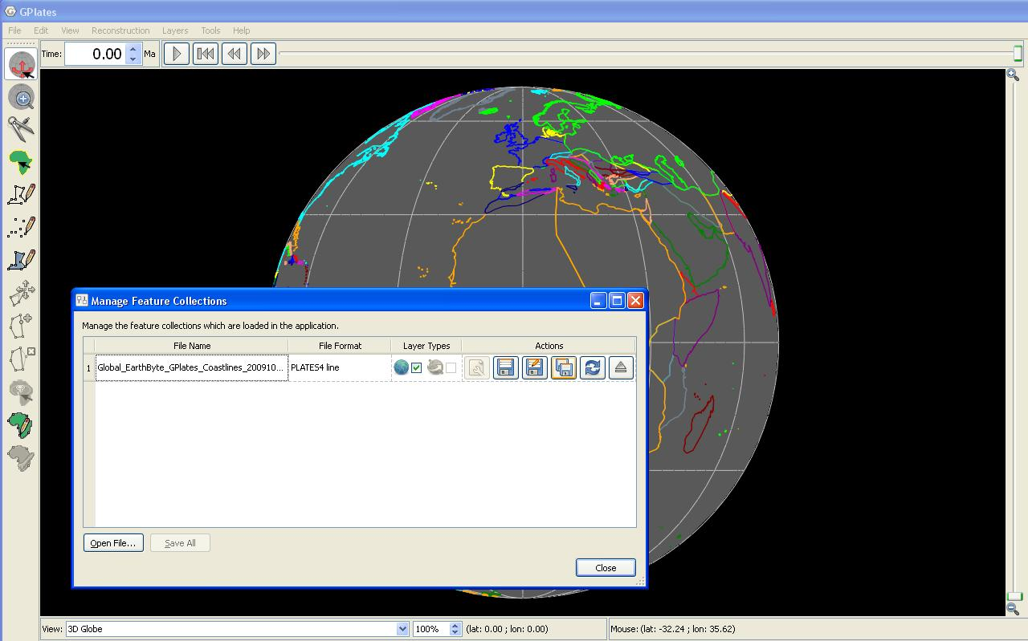
- Specify the name of the output shapefile, and select the ‘ESRI shapefile (*.shp)’ file type.
Click ‘Save’ to complete export. GPlates exports the geometry with the accompanying attribute information such as Plate ID, Name, etc. This means that this shapefile can be directly loaded in GPlates again.
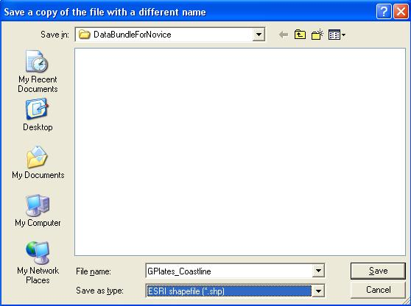

Loading GPlates data in ArcGIS
- Open a new empty map document in ArcMap.
- Click the ‘Add Data’ 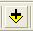 button in the main window.
- Navigate to the folder in which you saved “GPlates_Coastline.shp”.
You may need to click ‘Connect To Folder’ button to access some folders.
Once you have found your GPlates coastline file, select it and click ‘Add’.
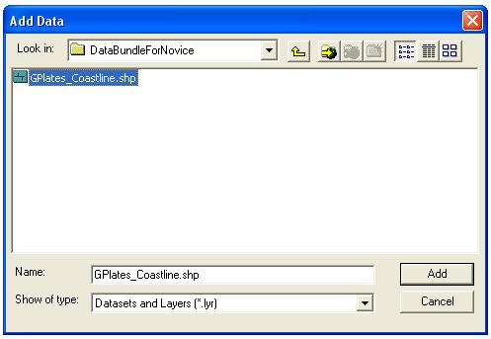
- The GPlates coastline contains feature attribute data. It may be useful to colour the coastline features by Plate ID. To do this, right-click on the “GPlates_Coastline” layer in the Table of Contents on the left side of the screen.
Click ‘Properties’ from the drop-down menu.
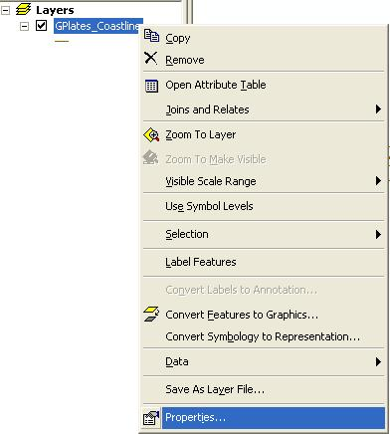
- Select the ‘Symbology’ tab in the Layer Properties screen. Click ‘Unique values’ under the Categories section. The value field is the feature attribute that the colour ramp will be assigned to.
Select the “PLATEID1” Value Field and choose a suitable colour ramp.
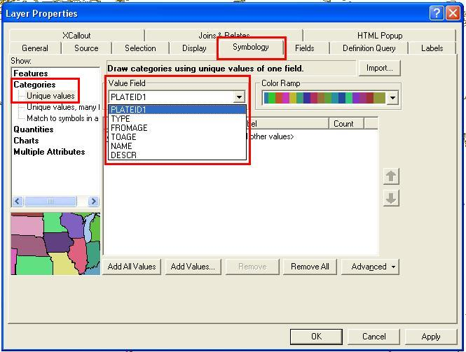
- Click ‘Add All Values’ to load all the Plate IDs from the shapefile. The next step will be to make the displayed lines thicker. Click the ‘Symbol’ column and select ‘Properties for All Symbols’.
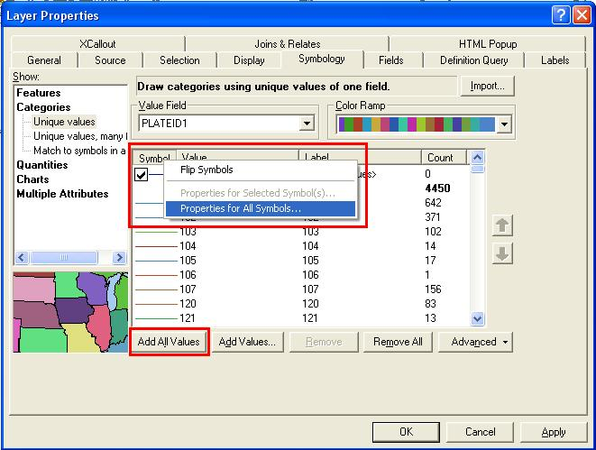
- Change the line width to ‘2.00’ points.
Leave all the other settings as their default value and click ‘OK’.
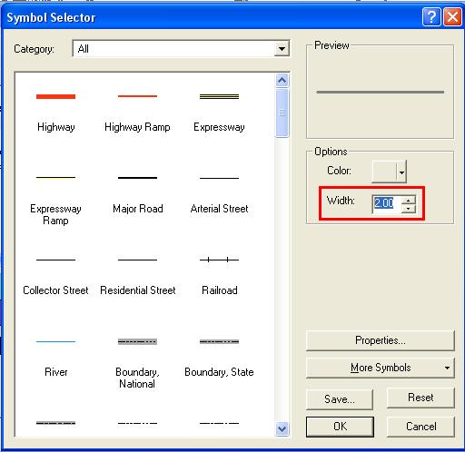
- Click ‘OK’ again to return to the map display window. The coastline will now be coloured by Plate ID. It will be essential to use the ‘Identify’ tool to query Plate IDs and other attributes. The figure below shows the Australasian region coloured by Plate ID.
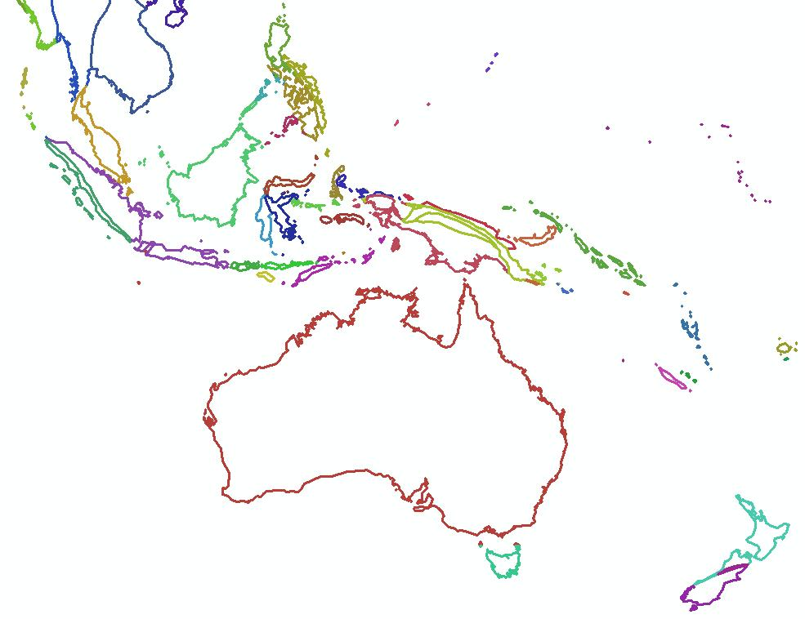
- To query the shapefile, select the ‘Identify’ tool and click on the desired feature. For example, clicking on the Australian coastline will display attribute information for that feature. The Plate ID of 801 belongs to Australia and will be used to assign Plate IDs to new shapefile features in the following sections.
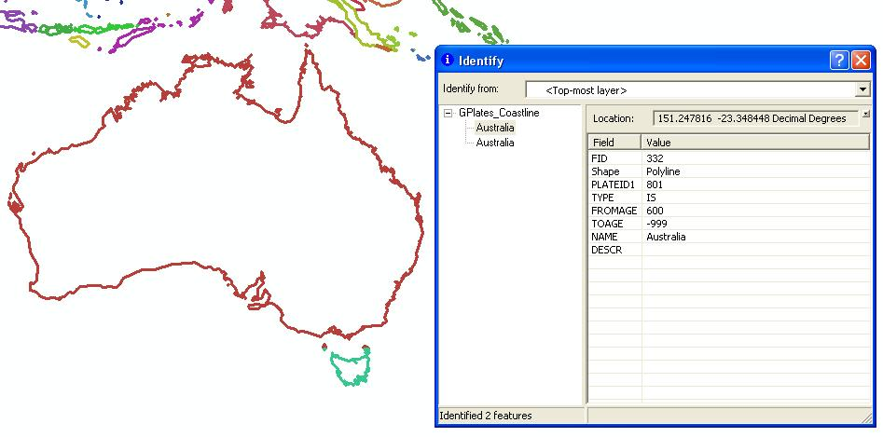
- Save your map document.

Assigning Plate IDs to geological provinces
As most external data that users are working with does not have assigned Plate ID, this tutorial section will describe the process of assigning Plate IDs to shapefile features in an external GIS environment such as ArcMap. This will allow you to load shapefiles directly in GPlates and reconstruct your data through time using the GPlates/EarthByte rotation model.
Additional data is available from:
http://www.earthbyte.org/Resources/earthbyte_gplates.html

- Open the map document from the previous section in ArcMap.
- Click the ‘Add Data’ button in the main window.
- Once prompted, navigate to the GPlates_SHP_Tutorial sample data folder.
- Select the following shapefiles:
CarpentariaBasin.shp, EuclaBasin.shp, MarionTerrain.shp and QLD_Plateau.shp
Click ‘Add’ to display these geological provinces.
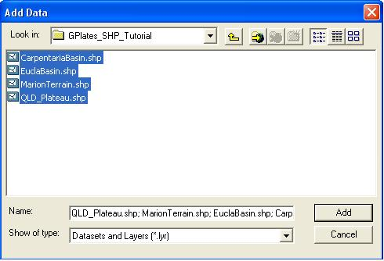
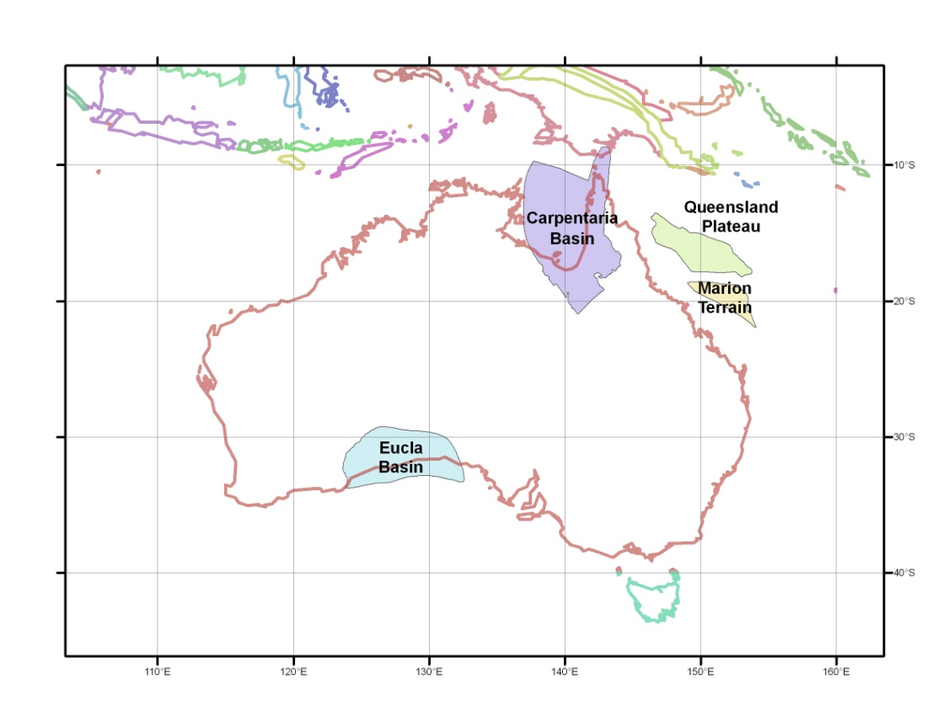
- Right-click on the “CarpentariaBasin” layer, and select ‘Open Attribute Table’.
The Attribute Table contains all the relevant information for the features in that selected shapefile. Fields can be added or deleted (be vary of this, they cannot be recovered once deleted) and attributes can be edited much like an ordinary spreadsheet.
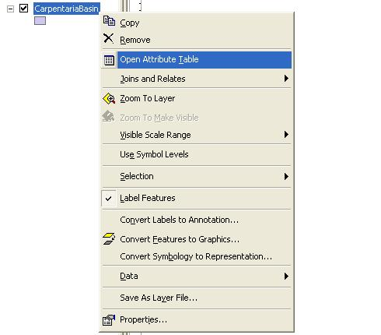
- The Attribute Table for the Carpentaria Basin contains only one polygon feature. We want to add a “PlateID” column (the ArcGIS term is ‘Field’) so that these geological provinces can be loaded into GPlates and reconstructed through time using the EarthByte rotation model.
In the Attribute Table click ‘Options’ → ‘Add Field’
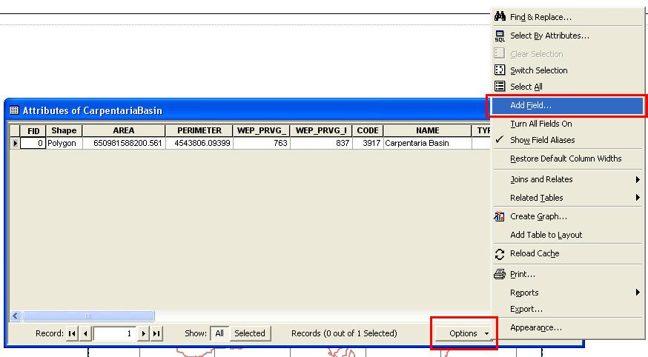
- Name the new field as “PlateID” and assign it the Short Integer data type. Click ‘OK’.
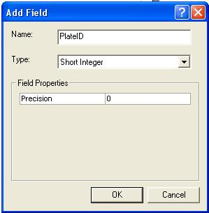
- Right-click on the ‘PlateID’ column heading, and select ‘Field Calculator’ from the drop-down menu. In the Field Calculator screen, type in 801 (without spaces) and click ‘OK’ to assign the Plate ID. When this shapefile is loaded into GPlates, this feature will reconstruct using the rotation entry for Plate ID 801 (Australia).
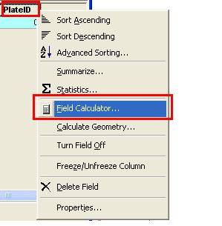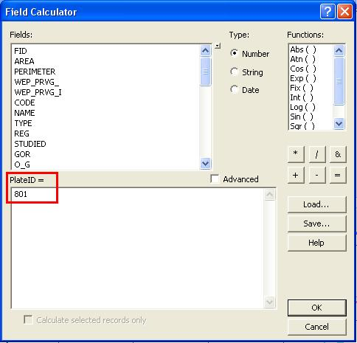
- Repeat Steps 5-8 for the other three geological provinces, adding a PlateID field and assigning the Plate ID of 801 to each shapefile.
Changes that are made using the Field Calculator are automatically appended to the shapefile. The shapefiles are now ready to be loaded in GPlates and reconstructed using the EarthByte rotation model.

Load geological province shapefiles in GPlates
- Open GPlates
Go to File → Manage Feature Collections → Open File…
Navigate to the “GPlates_SHP_Tutorial” folder, select the four geological province shapefiles and click ‘Open’.
The first time you load a shapefile in GPlates, you will be prompted to assign the fields that correspond to the GPlates model properties. For our purposes, ensure that the Name and Plate ID fields match by making the necessary selections from the drop-down lists. Click ‘OK’ and repeat this process for the other geological provinces. Warning messages regarding unknown feature types may appear upon loading, but can be ignored. This is because we have not assigned Feature Types in this exercise. The process is similar to Steps 5-8 if you want to add Feature Types to your data.
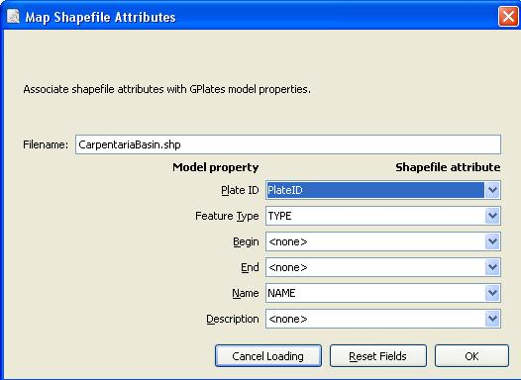
- Using the Manage Feature Collections screen (File → Manage Feature Collections), open the coastline and rotation file from the GPlates data bundle folder.
Click ‘Open File’ and navigate to the data bundle folder. Select your files and click ‘Open’.
Close the Manage Feature Collections screen to return to the main globe view.
The coastline and rotation files are now loaded. You can reconstruct your data, and you will notice that the four geological provinces will move with the Australian plate. In the example below, screen-shots from GPlates are taken at present day (0 Ma) and 20 million years in the past (20 Ma).
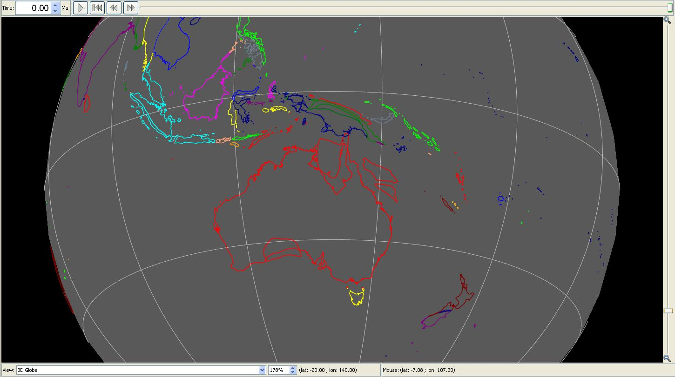
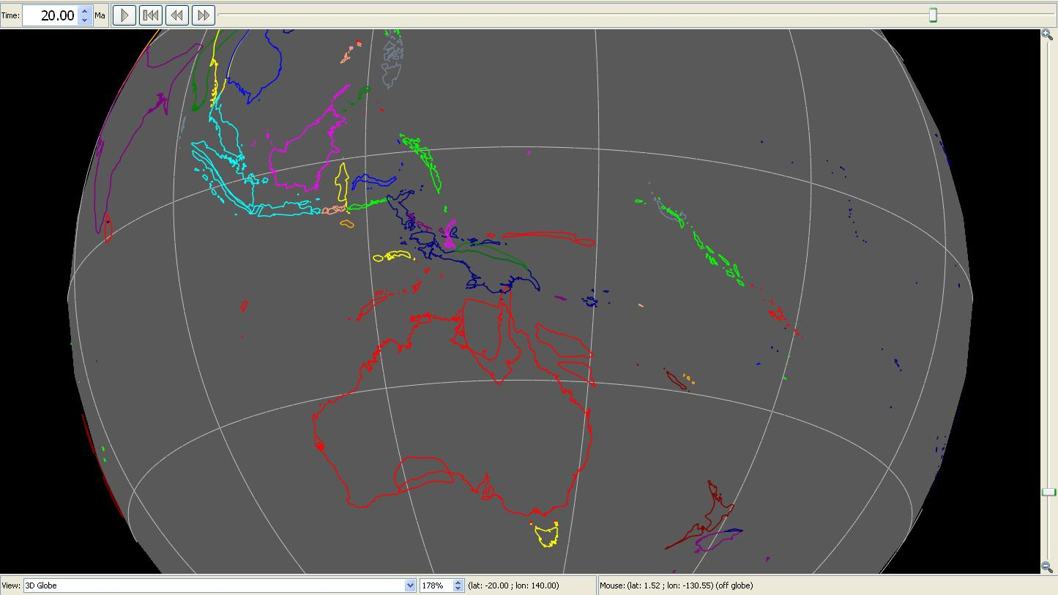

Visit www.gplates.org for more information.
Available from the provided sample data, or alternatively downloadable from the EarthByte website http://www.earthbyte.org/Resources/earthbyte_gplates.html Click “Download Data Bundle for Beginners”, and unzip this folder to a local directory.
Available for download from www.gplates.org

