***GPlates* Tutorial**

**Plate Reconstructions**

Grace E. Shephard1, Kara Matthews1 & Jo Whittaker1

1EarthByte Research Group, School of Geosciences, University of Sydney, Australia



www.gplates.org

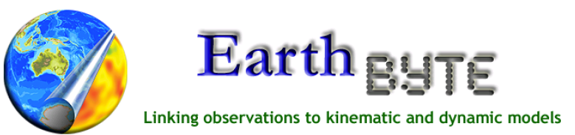

**AIMS**

This tutorial is designed to introduce:

* Plate ID’s and the plate hierarchy,
* Rotating features on the globe, and
* Exporting reconstructed geometries

We aim to provide a basic understanding of how plate rotation models work and how GPlates can be used to reconstruct features through time. You will then learn how to export reconstructed geometries so that they can be visualised, or further manipulated away from GPlates.

**INCLUDED FILES**

For this part of tutorial you will need these datasets found data bundle for this tutorial:

* Rotation Model: Global\_EarthByte\_GPlates\_Rotation\_20091015.rot
* Coastline File: Global\_EarthByte\_GPlates\_Coastlines\_20091014.gpml
* Plate ID Table: Global\_Earthbyte\_PlateIDs\_20100211.pdf (this document contains all the Plate ID’s we will be referring to, and that are contained in the EarthByte rotation model)

Additional datasets and files, including rotations, coastlines, isochrons, spreading ridges and COB files can be downloaded at the following site:

<http://www.earthbyte.org/Resources/earthbyte_gplates.html>

**BACKGROUND TO PLATE ROTATION MODELS**

If you do not have a background in plate motions, we recommend that you read Cox and Hart (1986). Below are some definitions used in this tutorial (see GPlates manual for further details):

**Plate ID:**

A Plate ID assigns a feature to a plate or tectonic element that has moved relatively to other plates for some period during its geological history. A Plate ID is a non-negative integer number. Tectonic elements can include anything from large plates to island arcs and relatively small blocks or terranes in regions experiencing complex deformation. In GPlates we also assign separate plate ID’s to pieces of oceanic crust that were transferred from one plate to another by a ridge jump or propagation. Even though such pieces of crust were always part of one plate or another, we need to assign it a separate plate ID to model this process. The fixed reference frame of the Earth’s spin axis is assigned plate ID 0, whereas sections of the Earth’s mantle that appear to have moved relatively coherently to other portions of the mantle can be assigned plate ID’s as well. For example the Atlantic-Indian hotspots are assigned plate ID 001, whereas Pacific hotspots are assigned plate ID 002. This remains so even for absolute plate motion models that consider relative motion between individual hotspots – however, each mantle plume can ultimately be assigned a plate ID as well, and motion of a given plume relative to the spin axis can be modeled by a set of finite rotations (even though these rotations are not unique). This illustrates that we use plate ID’s not only for physical tectonic plates. A list of Plate IDs and corresponding descriptions can be found in the document Global\_Earthbyte\_PlateIDs\_20100211.pdf.

**Finite Rotations:**

Euler's Displacement Theorem specifies that any displacement on the surface of the globe can be modelled as a rotation about some axis. This combination of axis and angle is called a finite rotation and can be expressed as a latitude, longitude and angle of rotation. Finite rotations are used by *GPlates* as the elementary building blocks of plate motion.

**Total Reconstruction Poles:**

Total Reconstruction Poles tie finite rotations to plate motion. A total reconstruction pole is a finite rotation which "reconstructs" a plate from its present day position to its position at some point in time in the past. It is expressed as the combination of a "fixed" Plate ID, a "moving" Plate ID, a point in time and a finite rotation.

Reconstructions are defined in a relative fashion; A single total reconstruction pole defines the motion of one plate id (the "moving" Plate ID) relative to another (the "fixed" Plate ID) at a specific moment in geological time. A sequence of total reconstruction poles is needed in order to fully model the motion of one particular plate across the surface of the globe throughout time.

**Anchored Plate ID:**

A sequence of total reconstruction poles is used to model the motion of a single plate across the surface of the globe. Total reconstruction poles describe the relative motion between plates, but ultimately this motion has to be traced back to a single Plate ID which is considered "anchored". *GPlates* calls this the Anchored Plate ID. Generally, this Plate ID corresponds to an absolute reference frame, such as a hotspot, paleomagnetic, or mantle reference frame. The convention is to assign the anchored Plate ID to 000, but *GPlates* allows any Plate ID to be used as the anchored Plate ID.

**The Rotation Hierarchy:**

To create the model of global plate rotations that is used in *GPlates*, total reconstruction poles are arranged to form a hierarchy, or tree-like structure. At the top of the hierarchy is the anchored Plate ID. Successive Plate IDs are further down the chain and linked by total reconstruction poles. To calculate the absolute rotation of a Plate ID of a feature with a given Plate ID (relative to the fixed reference defined by the anchored plate ID, at a given time), *GPlates* starts at that point in the hierarchy and works its way up to the top - to the root of the tree.

For example, in the GPlates-compatible 2008 EarthByte Global Rotation Model, the South American plate (also known by the abbreviation “SAM”, with plate ID 201) moves relative to the African plate (“AFR”, 701), as does the Antarctic plate (“ANT”, 802), while the Australian plate (“AUS”, 801) moves relative to the Antarctic plate. This is illustrated in Figure 1.

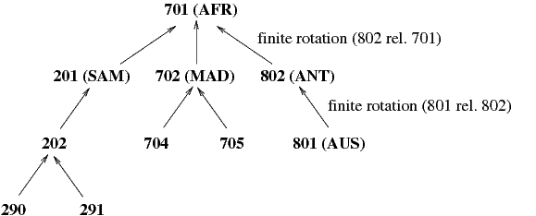

**Figure 1.** Sample of a simple rotation tree.

**Content of a rotation file:**

Figure 2 is a section from a rotation file. The basic content is the same in other file formats e.g. GPML.

Column 1: “Moving” Plate ID e.g. 611

Column 2: Time e.g. 0.0 (Ma)

Columns 3, 4, 5: Rotation poles. The first two are the coordinates of the pole of rotation (latitude, longitude), the third is the angle of rotation.

Column 6: Conjugate or “fixed” Plate ID (Rotations relative to this plate) e.g. 609

Column 7: Abbreviation of Plate and Conjugate Plate and name, and sometimes the relevant reference e.g. WPV-NPS West Parece Vela Basin – North Philippine Sea.

There are usually multiple entries for the same Plate ID, but with different times and rotation poles and, sometimes, different conjugate plates, to capture the rotation history of a give plate relative to neighboring, or conjugate plates. Which plate is assigned as a given plate’s conjugate depends on the user. Generally this choice is determined by where most of the constraints for reconstructing the relative motion history are, and this can be time-dependent.

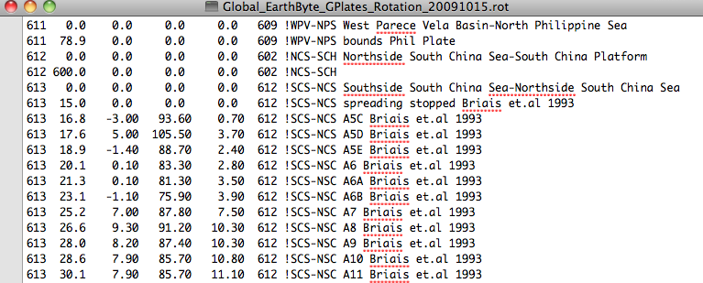

**Figure 2.** Sample of a rotation file.

**EXERCISE 1: The Plate Hierarchy**

Here we will see what the plate hierarchy looks like in *GPlates*.

1. Open *GPlates*
2. File > Open Feature Collection (Figure 3) > navigate to the GPlates\_Rotations\_Tutorial directory and select **Global\_EarthByte\_GPlates\_Coastlines\_20091014.gpml** and **Global\_EarthByte\_GPlates\_Rotation\_20091015.rot** > Open

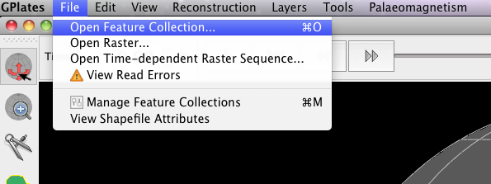

**Figure 3.** Opening a new feature collection from the Main Menu.

1. Click and drag the globe to rotate it so that it is centered on the South Atlantic. You will see that all the plates are coloured according to their plate ID. Use the Choose Feature tool :::Tutorial_ScreenShots:ChooseFeature.tiff to select and query some of the features.

We will now view the plate hierarchy of the files loaded.

1. Reconstruction > View Total Reconstruction Poles (Figure 4) > Reconstruction Tree (third tab, Figure 5). Click Expand All to view the whole tree.

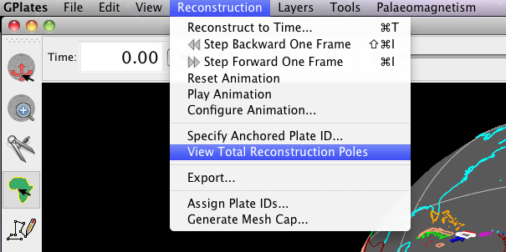

**Figure 4.** Navigating to View Total Reconstruction Poles from the Main Menu.

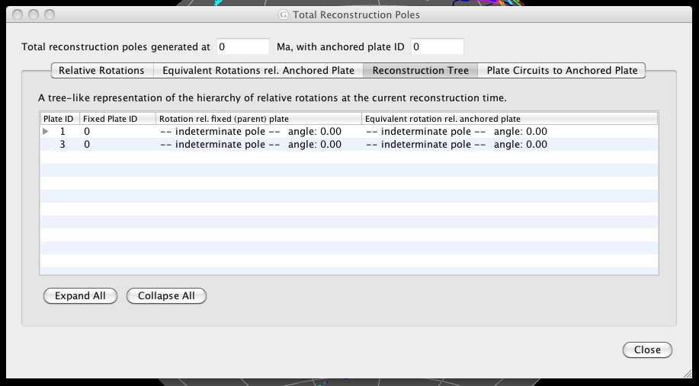

**Figure 5.** The plate hierarchy is found under the Reconstruction Tree tab in the Total Reconstruction Poles window (third tab).

You will see that the highest entry id is Plate ID 1 (001 – Atlantic-Indian hotspots) which is fixed to 0 (000 – Earth’s spin axis).

1. Click the small triangle to the left of the ‘1’, this will reveal the next highest plate in the plate hierarchy - Plate 701 (Africa) (Figure 6).

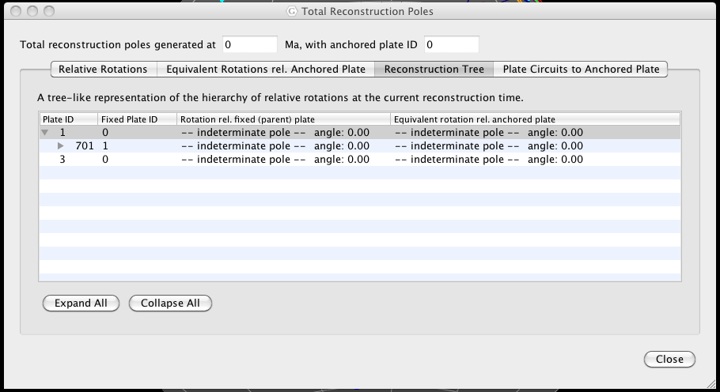

**Figure 6.** Expanding Plate ID 1, you reveal the next highest plate in the plate hierarchy.

1. Now expand the tree even further by clicking the small triangle next to Plate ID 701. You will see that plates 201, 307 503, 507 etc move relative to 701, which in turn moves relative to 001, which in turn is fixed to 000 (Figure 7).

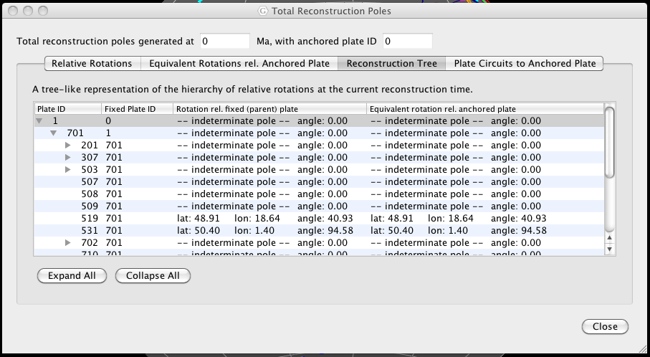

**Figure 7**. The plate hierarchy tree for our loaded files.

By expanding the tree, click Expand All, you can see how all the plates in the Coastline file move through time, i.e. which plates they move relative to.

Changing something high in the rotation tree will effect the absolute rotations of all lower plates (relative motions will remain the same). For example, you may notice that the South American continent is divided into several plates with different Plate IDs. Rotating Plate ID 201 will subsequently move the lower Plate IDs 202, 203… etc, however, if you rotate Plate ID 202, Plate 201 will not be moved as it is higher than 202. You can always check the conjugate plate by looking at the information of a particular plate, or checking the reconstruction tree as above.

**EXERCISE 2: Reconstructing Data on the Globe**

Now that you have some understanding of how a plate hierarchy works, and therefore the basics of a plate reconstruction model, it is a good idea to spend some time actually reconstructing the coastline data. We will now employ the rotation file to reconstruct our coastlines back to 100 Ma,

The easiest way to reconstruct data is by using the Time (Figure 8) and Animation tools (Figure 9).



**Figure 8.** The Time tools enable you to jump to a certain time.



**Figure 9.** The Animation tools in the Main Window enable you to reconstruct data back and forth through time.

A quick and way to jump straight to a certain time is by using the Time Controls. Simply enter the time you wish to reconstruct to and press enter.

1. In the Time Controls box type 100 Ma > Enter. Rotate the globe and have a look at where the continents were 100 Ma (Figure 10).

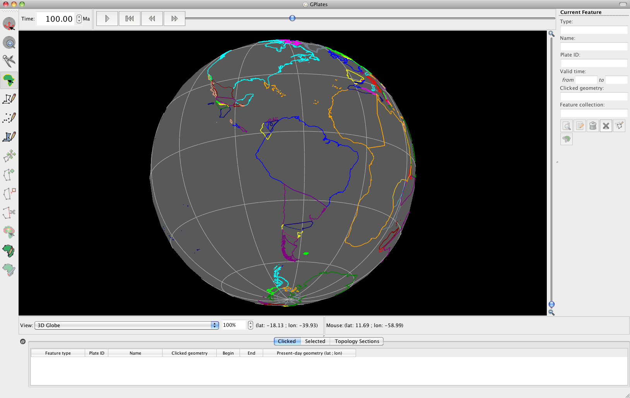

**Figure 10.** View of the coastlines at 100 Ma. Note that in the Time Controls box (top left) the time says 100.00 Ma.

An alternative way to reconstruct your data is by using the Animation controls. You can simply click and manually move the time slider (notice that in Figure 10, the slider is no longer at the far right but is a third of the way along) or you may jump to a certain time and then “play” an animation of the feature data reconstructing.

1. Make sure that you are still at 100 Ma (or jump to any time in the past) > press the play button in the Animation Controls  and watch the coastlines rotate back to their present-day positions. To animate the entire time period you have rotations for, first use the Reset button  to take you back to the oldest time you have rotations for and then press play.

You may also watch animations of your data by using the Configure Animation option from the Reconstruction menu (Figure 11).

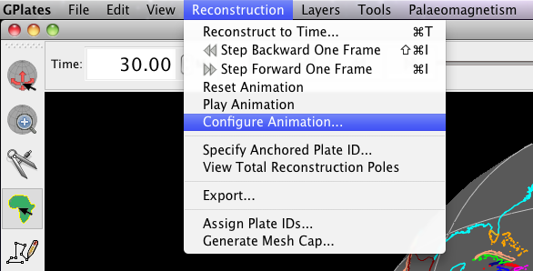

**Figure 11.** Animations can be manually configures from the Reconstruction menu.

The Animate window provides you additional control over your animation (Figure 12). For example, you can specify whether you want to watch a reconstruction run backwards or forwards through time by clicking the Reverse the Animation button.

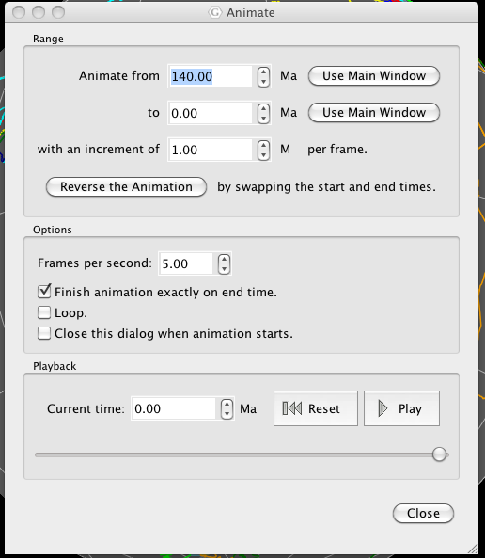

**Figure 12.** The Animate window allows you to specify details about your animations.

GPlates also enables you to change the anchored plate (Figures 13) so that you can reconstruct data keeping different plates fixed.

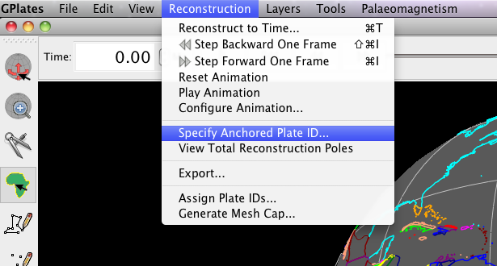

**Figure 13.** GPlates enables you to specify which Plate ID you keep fixed when reconstructing data.

Spend some time altering the anchored plate ID to see the influence on the plate motions. For example, make an animation keeping South America fixed.

1. Reconstruction > Specify Anchored Plate ID… > 201 > OK (Figures 13 and 14)

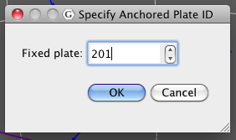

**Figure 14.** Nominating which plate to keep fixed.

Once you have finished experimenting, set your anchored plate back to 000 (the spin axis – default).

**EXERCISE 3: Rotating features on the globe**

In this exercise, we will cover the basics on how to rotate a feature on the globe.

In the early 20th century, Alfred Wegener proposed that all continents might once have existed as a single supercontinent. He realised that the coastlines of eastern South America and western Africa fit together like a jig-saw puzzle. Let us use GPlates to replicate Wegener’s initial work.

1. With the coastline and rotation files already loaded from the last exercise, click and drag the globe to rotate it so that it is centered on the South Atlantic. Make sure you are at 0 Ma.
2. Our aim is to visually fit South America to Africa i.e. rotate South America relative to Africa. To select the feature to rotate (South America), click the select feature iconScreen shot 2010-01-27 at 5, and then click somewhere on the South American coastline. This will highlight the feature as a white outline (Figure 15). The feature attributes should appear in the panels to the right and bottom of the main reconstruction window. You will notice that the South American Craton has Plate ID 201. Click on the Africa coastline. What Plate ID corresponds to Africa?

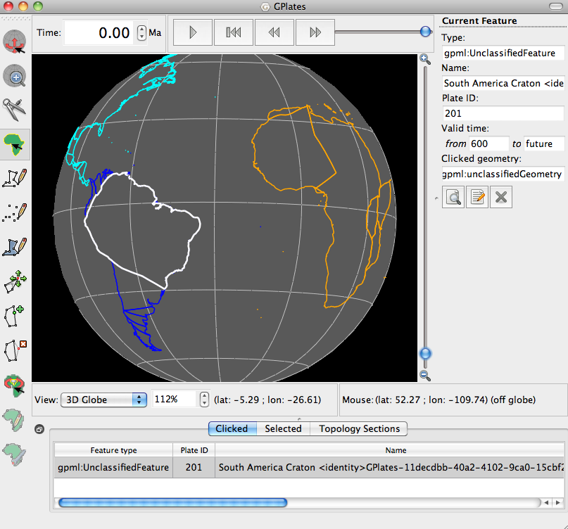

**Figure 15.** The South American coastline has been selected.

1. Next, click on the Modify Reconstruction Pole Screen shot 2010-01-28 at 11 tool. Note that any changes to a rotation pole for a particular Plate ID will affect all other features assigned to that particular rotation pole. In our case, all the coastlines that move relative to Plate ID 201 will be affected.
2. After the feature has been selected by clicking anywhere on the coastline it can be moved anywhere on the globe by dragging (the feature will rotate about a point in the centre of the screen). The new location of the plate will be outlined in light grey (Figure 16). If at first you are not happy with the new location of South America, just click and drag again as appropriate. The feature can also be rotated about its axis by holding down SHIFT and dragging.

Note: the globe can still be re-oriented whilst holding down the Command (Mac)/Control(PC) key while in the “Modify Reconstruction Pole” mode. Information regarding the reconstruction pole is displayed in the task panel to the right. This includes the Plate ID of the feature you are moving and the new rotation pole that will be applied if this location is confirmed by pressing Apply (applying rotations will be dealt with in the Rotations tutorial).

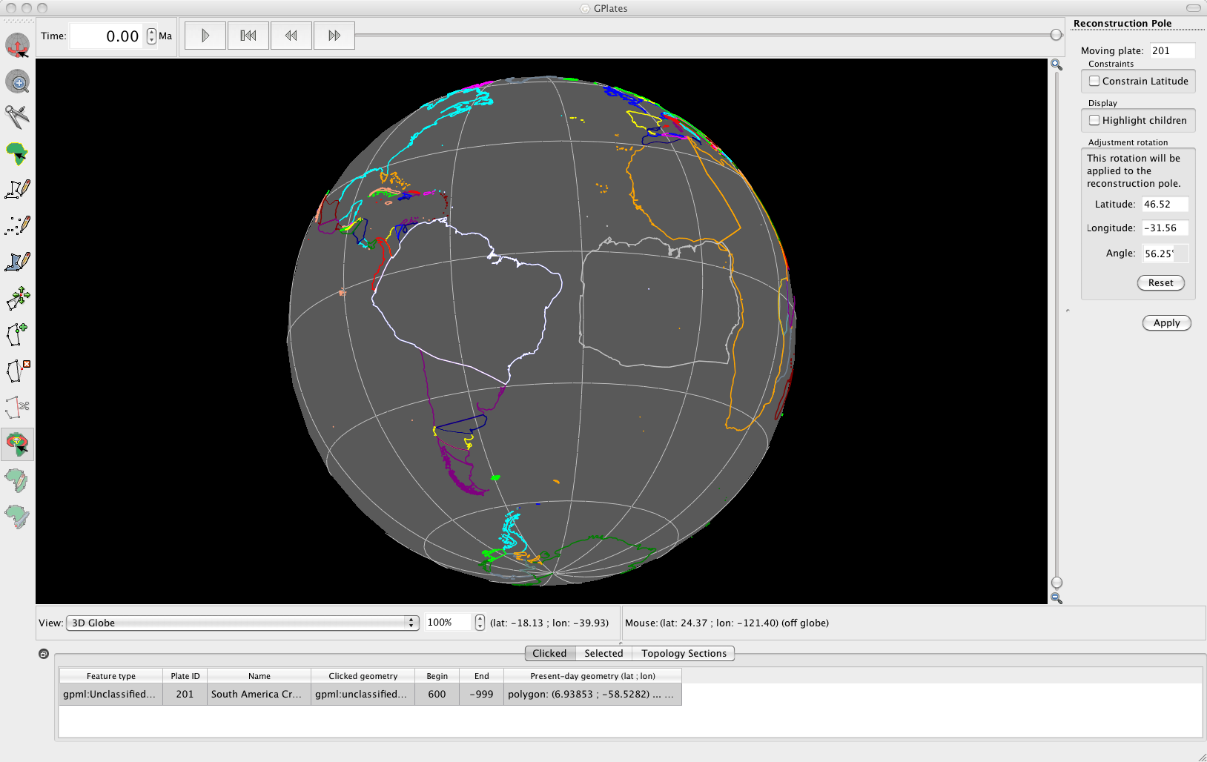

**Figure 16.** Rotating and re-orienting South America.

As mentioned above, changing a rotation pole for a particular Plate ID will affect all other features assigned to that particular rotation pole. GPlates enables you to see which plates will be influenced by your changes. Whilst using the Modify Reconstruction Pole tool you can choose to “Highlight children”, i.e. show plates that move relative to the plate you have selected.

1. Tick Highlight children to the right of the globe (Figure 17 and 18) and notice the additional coastlines that move with South America and would be affected if you were to reconstruct South America differently.

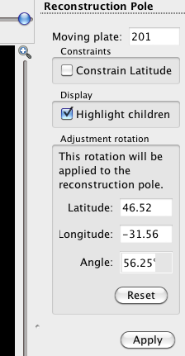

**Figure 17.** Highlighting children plates will enable you to see the implications of changing a particular rotation pole.

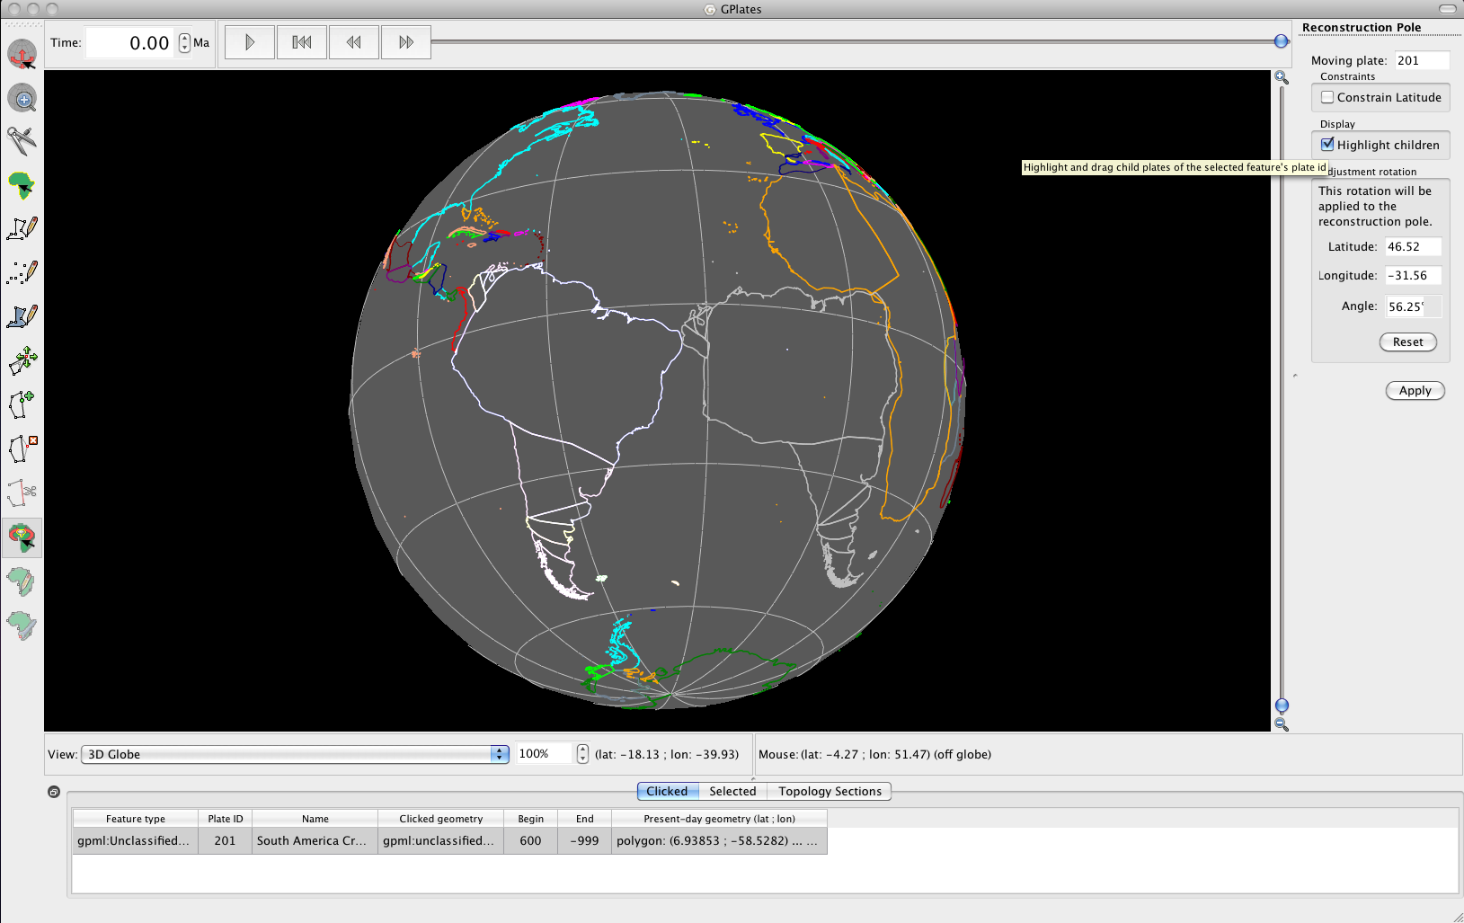

**Figure 18.** Rotated South America, showing the Plate ID’s (“children”) that would be influenced by the move.

In the Rotation tutorial we will learn more about applying and modifying rotations. Do not apply this rotation now, simply click a different tool and the grey South America will disappear,

**EXERCISE 4: Exporting Reconstructed Geometries**

GPlates allows you to export reconstructed geometries, either for a single snap shot or a sequence of snap shots. This functionality allows you to extract palaeo-coordinates for feature data that you have reconstructed back through time using a rotation model. Reconstructed geometries can be exported as a file containing longitudes and latitudes (i.e. in the GMT format, \*.xy) or in the shapefile format to be used in GIS software.

To illustrate this procedure we will export reconstructed geometries for our coastlines.

1. Reconstruction > Export… (Figure 19)

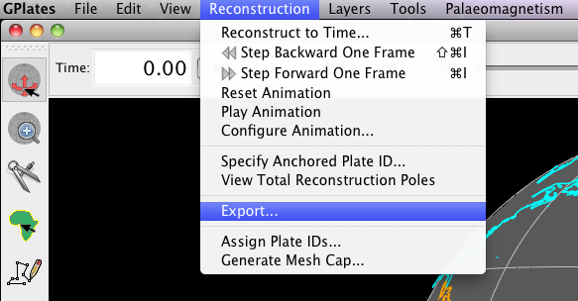

**Figure 19.** Navigating to the Export window.

The Export Animation window is where you specify what type of data you are exporting and for which period of time. We will export our coastline geometries for the time period 50 Ma – 0 Ma, with an increment of 5 Myr.

1. First we will change the ‘Animate from’ field to 50.00, and the ‘with and increment of’ field to 5.00 (Figure 20).

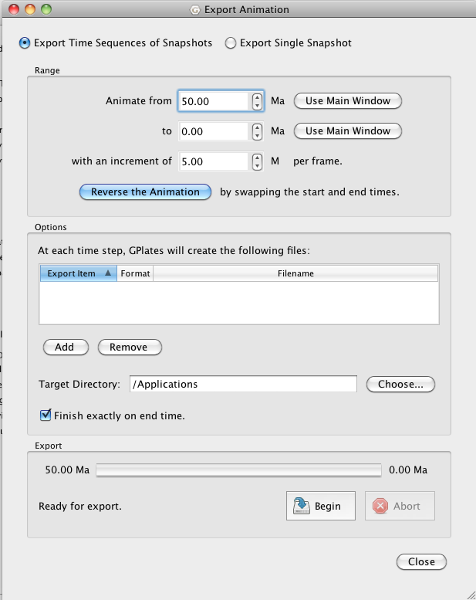

**Figure 20.** The Export Animation window.

1. Next we must select which files we want GPlates to create. Add > select the Reconstructed Geometries option from the top box > choose the GMT (\*.xy) format > Add > Close (Figure 21)

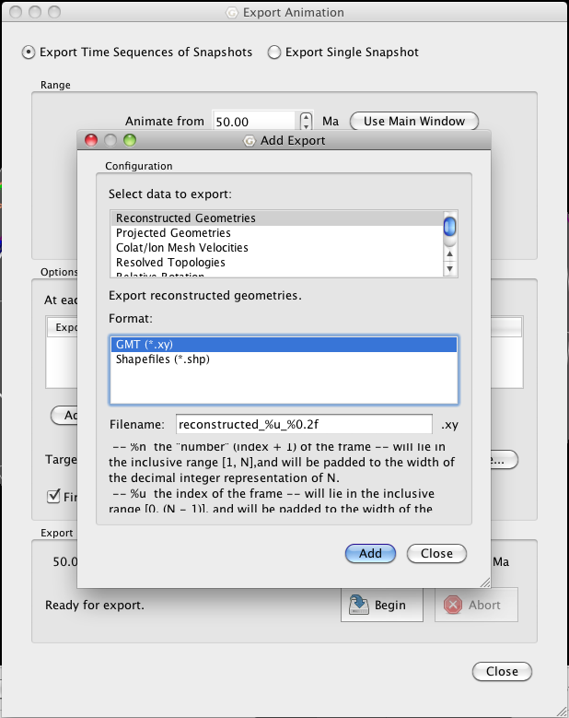

**Figure 21.** The Add Export window allows you to select which data you want to export, and in which format.

1. Now ensure that you have selected a target directory where your files will be created (Figure 22). When you are satisfied with all the criteria click Begin (bottom right).

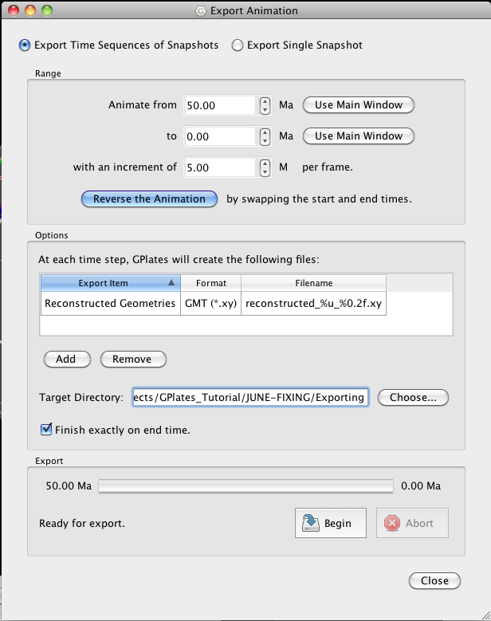

**Figure 22.** Once all the Export Animation fields have been filled hit Begin in the bottom right corner.

1. Go to the target directory where your files have been sent. You will notice that GPlates has named the files according to the time the data is for and the number the file is in the sequence of files. The first file is named **reconstructed\_00\_50.00.xy**, the second file is **reconstructed\_01\_45.00.xy** etc. Open one of the files and have a look at the output.

These data can now be plotted using GMT, for example. This GPlates function allows for quick and easy extraction of palaeo-coordinates for use outside of GPlates.

Note: GPlates will extract the reconstructed geometries of **all** feature data actively being displayed on the Globe. Therefore, turn off the data you do not wish to export the reconstructed geometries for. For example, if you also had the EarthByte Continent-Ocean Boundaries displayed on the globe but you did not wish to extract their reconstructed geometries, then you would go to File > Manage Feature Collections > untick the layer box, then follow the procedure above.

**References:**

[**Cox**](http://www.sciencedirect.com/science?_ob=ArticleURL&_udi=B6VHG-455TCJR-1&_user=115085&_coverDate=04%2F30%2F2002&_rdoc=1&_fmt=high&_orig=search&_sort=d&_docanchor=&view=c&_rerunOrigin=scholar.google&_acct=C000008818&_version=1&_urlVersion=0&_userid=115085&md5=4ea07623b3b056e61d7dea923ac49297#bbib80)**, A. and Hart, R.B**., 1986. *Plate Tectonics: How it Works*, Blackwell Scientific Publications, Oxford 392 pp .