***GPlates* Tutorial**

**Preparing Data in ArcGIS for GPlates**

Sabin Zahirovic1

1EarthByte Research Group, School of Geosciences, University of Sydney, Australia



www.gplates.org



The vast majority of users that deal with geospatial data are likely to be using commercial or open-source GIS packages to display and edit their data. This tutorial will help you create and prepare data in ArcGIS (a common commercial GIS package) for viewing in GPlates[1]. It is important to note that GPlates will import any shapefile (assuming it conforms to shapefile standards), and can export shapefiles for use in other GIS platforms.

The tutorial will involve loading GPlates data into ArcGIS to familiarise the user on the file conversion capabilities of GPlates. The later section deals with adding GPlates attributes, such as Plate IDs, to selected geological provinces in ArcMap, in order to create a shapefile that can be loaded into GPlates and reconstructed using the EarthByte rotation model.

***Note:*** *The shapefiles associated with this tutorial are in a WGS 84 geographic datum. If you are working in another projection within ArcGIS, you may need to apply a geographic transformation to the data. This is reasonably straight-forward and automatic in most GIS packages. Refer to the manual of your GIS package for more information.*

**Required data:**

* GPlates data bundle (i.e. DataBundleForNovice folder)[2]
* ArcGIS tutorial data bundle

## Loading GPlates data in ArcGIS

1. Open a new empty map document in ArcMap.
2. Click the ‘Add Data’ 2.JPG button in the main window.
3. Navigate to the data bundle for this tutorial and open “GPlates_Coastline.shp” (this is the file we worked on in the Shapefiles tutorial).   
     
   You may need to click ‘Connect To Folder’ 6.JPG button to access some folders.   
     
   Once you have found your GPlates coastline file, select it and click ‘Add’.   
     
   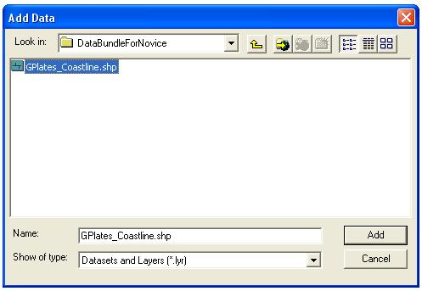
4. The GPlates coastline contains feature attribute data. It may be useful to colour the coastline features by Plate ID. To do this, right-click on the “GPlates_Coastline” layer in the Table of Contents on the left side of the screen.   
     
   Click ‘Properties’ from the drop-down menu.  
     
   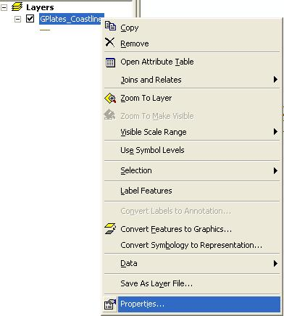
5. Select the ‘Symbology’ tab in the Layer Properties screen. Click ‘Unique values’ under the Categories section. The value field is the feature attribute that the colour ramp will be assigned to.   
     
   Select the “PLATEID1” Value Field and choose a suitable colour ramp.  
     
   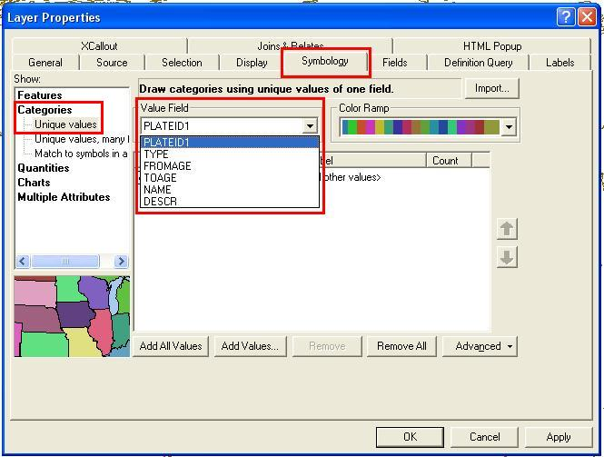
6. Click ‘Add All Values’ to load all the Plate IDs from the shapefile. The next step will be to make the displayed lines thicker. Click the ‘Symbol’ column and select ‘Properties for All Symbols’.   
     
   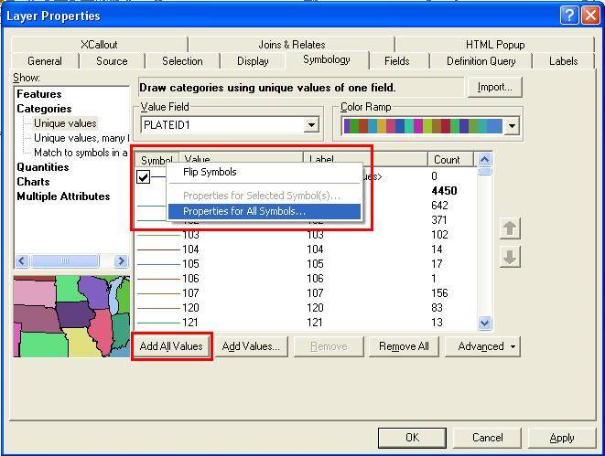
7. Change the line width to ‘2.00’ points.   
     
   Leave all the other settings as their default value and click ‘OK’.  
     
   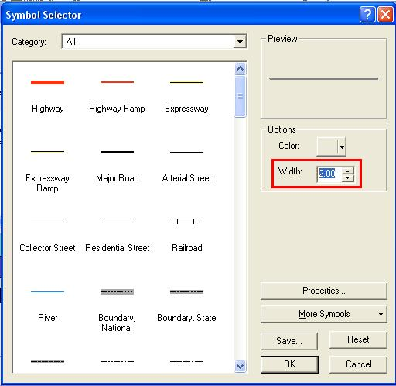
8. Click ‘OK’ again to return to the map display window. The coastline will now be coloured by Plate ID. It will be essential to use the ‘Identify’ 12.JPG tool to query Plate IDs and other attributes. The figure below shows the Australasian region coloured by Plate ID in an ArcGIS window.   
     
   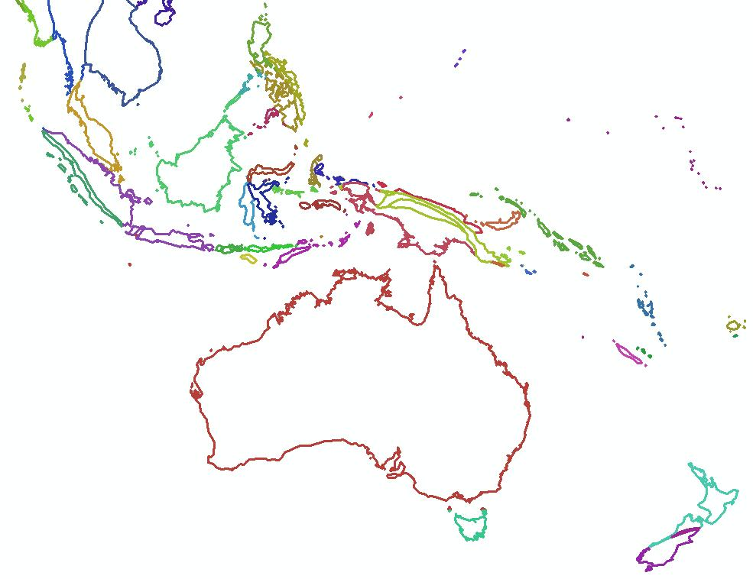
9. To query the shapefile, select the ‘Identify’ 12.JPG tool and click on the desired feature. For example, clicking on the Australian coastline will display attribute information for that feature. The Plate ID of 801 belongs to Australia and will be used to assign Plate IDs to new shapefile features in the following sections.  
     
   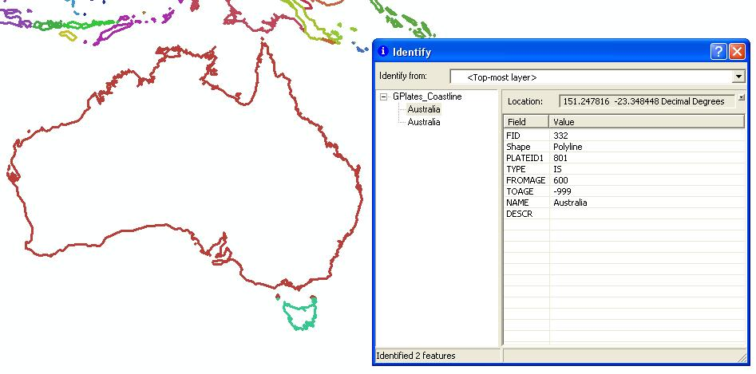
10. Save your map document.

# Assigning Plate IDs to geological provinces

This tutorial section will describe the process of assigning Plate IDs to shapefile features in an external GIS environment such as ArcMap. This is because most of the data users work with does not have assigned Plate IDs. This step will allow you to load shapefiles directly in GPlates and reconstruct features through time using the GPlates/EarthByte rotation model.

***Additional data is available from****:* [*http://www.earthbyte.org/Resources/earthbyte_gplates.html*](http://www.earthbyte.org/Resources/earthbyte_gplates.html)

1. Open the map document from the previous section in ArcMap.
2. Click the ‘Add Data’ 2.JPG button in the main window.
3. Once prompted, navigate to the ArcGIS Tutorial sample data folder.
4. Select the following shapefiles:  
     
   ***CarpentariaBasin.shp, EuclaBasin.shp, MarionTerrain.shp***and***QLD_Plateau.shp***Click ‘Add’ to display these geological provinces.  
   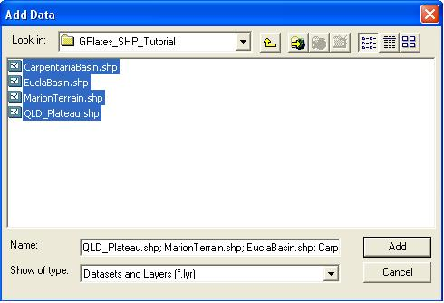  
   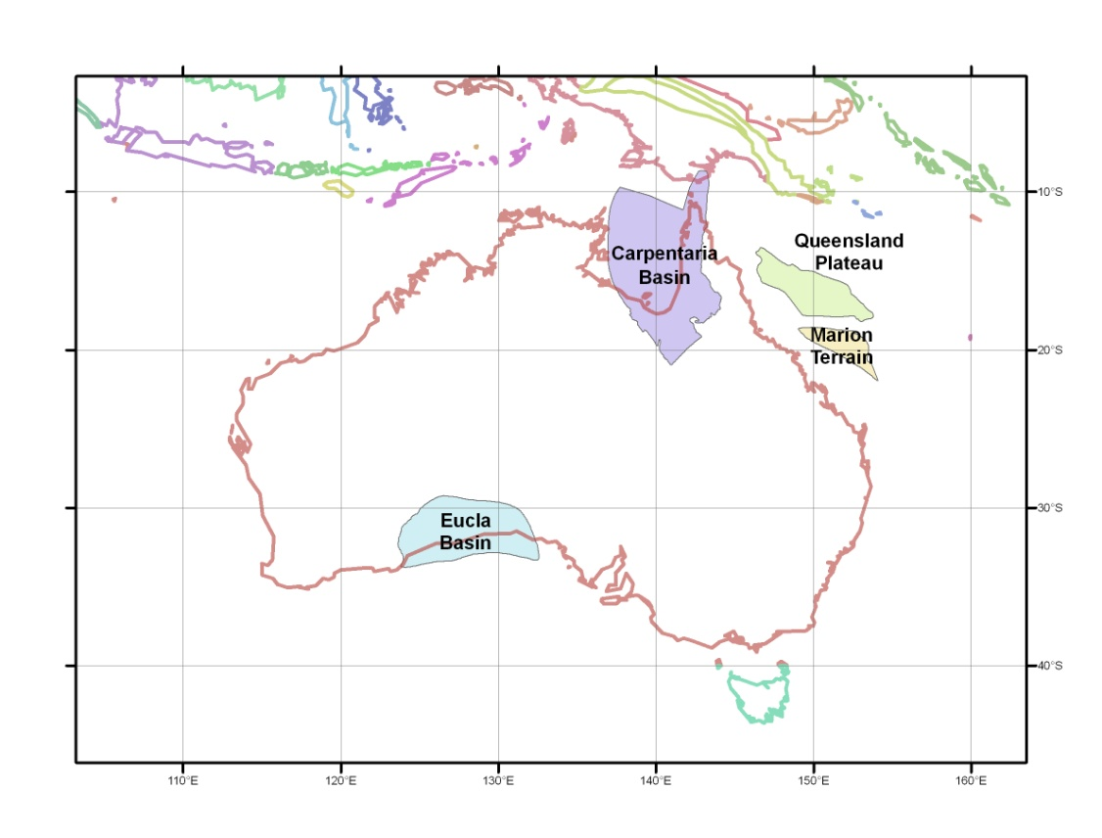
5. Right-click on the “CarpentariaBasin” layer, and select ‘Open Attribute Table’.   
     
   The Attribute Table contains all the relevant information for the features in that selected shapefile. Fields can be added or deleted (be vary of this, they cannot be recovered once deleted) and attributes can be edited much like an ordinary spreadsheet.   
     
   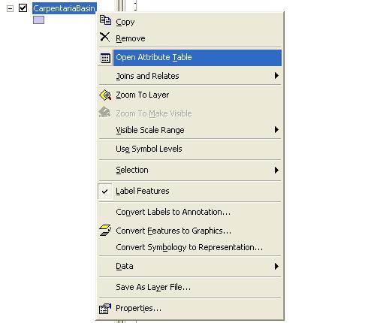
6. The Attribute Table for the Carpentaria Basin contains only one polygon feature. We want to add a “PlateID” column (the ArcGIS term is ‘Field’) so that these geological provinces can be loaded into GPlates and reconstructed through time using the EarthByte rotation model.   
     
   In the Attribute Table click ‘Options’ 🡪 ‘Add Field’  
     
   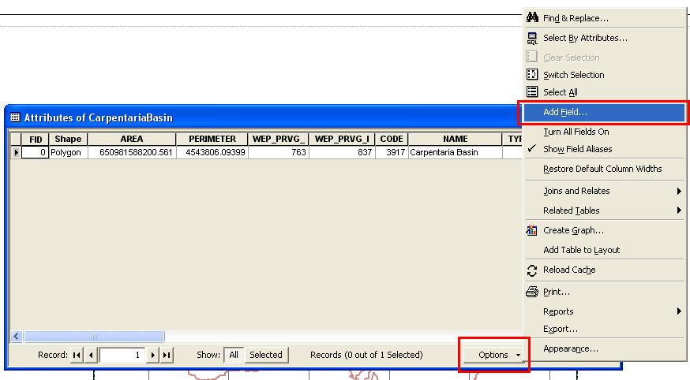
7. Name the new field as “PlateID” and assign it the Short Integer data type. Click ‘OK’.   
     
   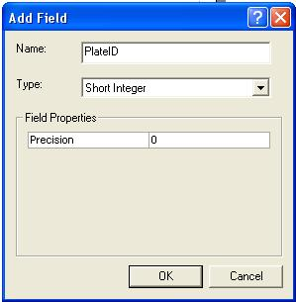
8. Right-click on the ‘PlateID’ column heading, and select ‘Field Calculator’ from the drop-down menu. In the Field Calculator screen, type in 801 (without spaces) and click ‘OK’ to assign the Plate ID. When this shapefile is loaded into GPlates, this feature will reconstruct using the rotation entry for Plate ID 801 (Australia).   
     
   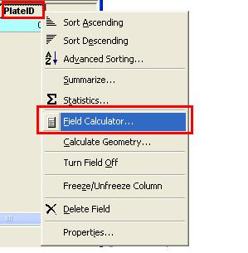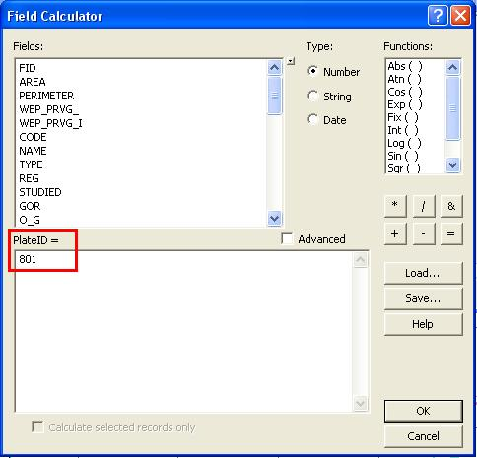
9. Repeat Steps 5-8 for the other three geological provinces, adding a PlateID field and assigning the Plate ID of 801 to each shapefile.   
     
   Changes that are made using the Field Calculator are automatically appended to the shapefile. The shapefiles are now ready to be loaded in GPlates and reconstructed using the EarthByte rotation model.

***Note:*** In case you want to make changes to individual records in the shapefile using the shapefile Attribute Table in ArcMap, you will need to enter an edit session. This is outside the scope of this tutorial – refer to the ArcGIS documentation on how to use ‘Editor’.

1. *Visit* [*www.gplates.org*](http://www.gplates.org) *for more information.*
2. *Available from the provided sample data, or alternatively downloadable from the EarthByte website* [*http://www.earthbyte.org/Resources/earthbyte_gplates.html*](http://www.earthbyte.org/Resources/earthbyte_gplates.html) *Click “****Download Data Bundle for Beginners****”, and unzip this folder to a local directory.*