***GPlates* Tutorial**

**Rotations**

Grace E. Shephard1, Kara J. Matthews1, Jo Whittaker1 & R. Dietmar Müller1

1EarthByte Research Group, School of Geosciences, University of Sydney, Australia



www.gplates.org



**AIM**

This tutorial is designed to teach the basics of implementing and manipulating rotations in GPlates. You will employ and build on the skills you acquired in the Plate Reconstructions tutorial.

**INCLUDED FILES**

For this part of tutorial you will need these datasets:

**Rotation Models:** AusAnt\_ExampleRotation.rot & Global\_EarthByte\_GPlates\_Rotation\_AusAnt\_Example.rot

**Coastline File:** Global\_EarthByte\_GPlates\_Coastlines\_20091014.gpml

**Fracture Zone File:** AusAnt\_FZs.gpml

**EXERCISE 1: Applying a rotation**

In the Plate Reconstructions tutorial you learnt how to move features around on the globe using the Modify Reconstruction Pole tool Screen shot 2010-01-28 at 11., we used the example of moving South America to fit together with Africa, like a jig-saw. It is more likely for tectonic reconstructions that you will want to change the rotation of a feature or apply a rotation to a feature back in time, rather than changing anything at the present-day. In this exercise we will learn how to implement a rotation. We will start off with a very simple example, using a very small rotation file.

Australia started to move away from Antarctica ~83 Ma. According to Tikku and Cande (1999) Australia moved in a northward direction relative to a fixed Antarctica. You will implement this rotation in the rotation file you have been provided, **AusAnt\_ExampleRotation.rot**. This file only contains rotations for Australia and Antarctica, for simplicity and so you can learn the basics of implementing rotations.

1. Open AusAnt\_ExampleRotation.rot in a text editor so you can see what it looks like (Figure 1):
   1. Plate ID 000 = Spin axis
   2. Plate ID 001 = Atlantic hotspots
   3. Plate ID 701 = Africa
   4. Plate ID 801 = Australia
   5. PlateID 850 = Tasmania
   6. Plate ID 802 = Antarctica

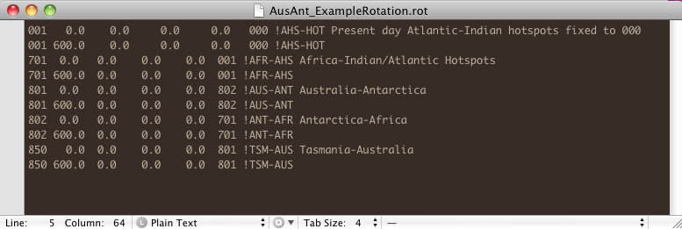

**Figure 1.** The contents of our example rotation file.

You will notice that Australia moves relative to Antarctica, Antarctica moves relative to Africa, Africa moves relative to the hotspot reference frame which is fixed to the spin axis.

1. Open GPlates
2. File > Open Feature Collection… (Figure 2) > select AusAnt\_ExampleRotation.rot and the EarthByte coastline file from the sample data bundle for this tutorial > Open

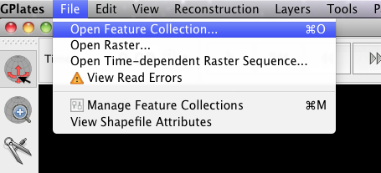

**Figure 2.** Loading feature collections into GPlates

1. Rotate the globe so that it is centred on Australia. Now reconstruct backwards through time. You will notice that the feature data stay fixed in their present-day locations (this is because they have no relative rotations). The only thing that changes is that features will disappear if you reconstruct to before their ‘appear time’.

It is generally believed that Australia moved northwards, relative to a fixed Antarctica, between ~83 Ma and the present (Tikku and Cande, 1999). We will implement this rotation.

1. Centre your globe so that Australia and the coastline of Antarctica nearest Australia are in view (Figure 3).

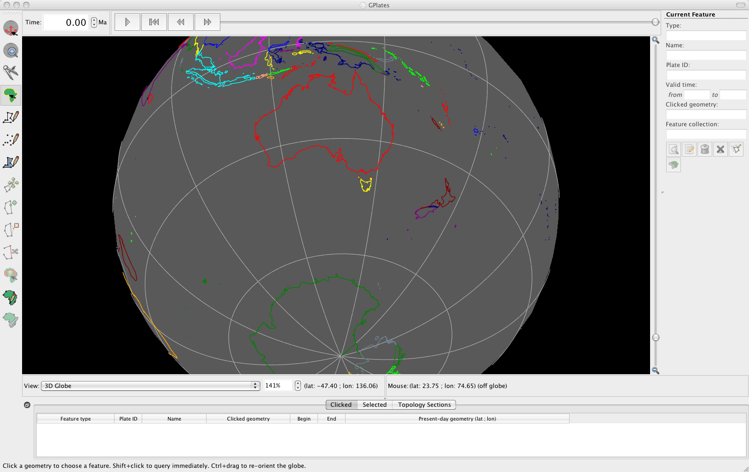

**Figure 3.** View of Australia and Antarctica.

1. As we want to implement a rotation at 83 Ma, jump to this time using the Time controls.
2. Use the Choose Feature tool :::Tutorial_ScreenShots:ChooseFeature.tiff to select Australia and then click Modify Reconstruction Pole Screen shot 2010-01-28 at 11.
3. Drag Australia in a southward direction so that it approximately lines up with Antarctica (Figure 4). Once the feature attains the desired position and orientation, clicking Apply (right of the globe), this will open up Apply Reconstruction Pole Adjustment window, where you can review the details of your implemented rotation (Figure 5).

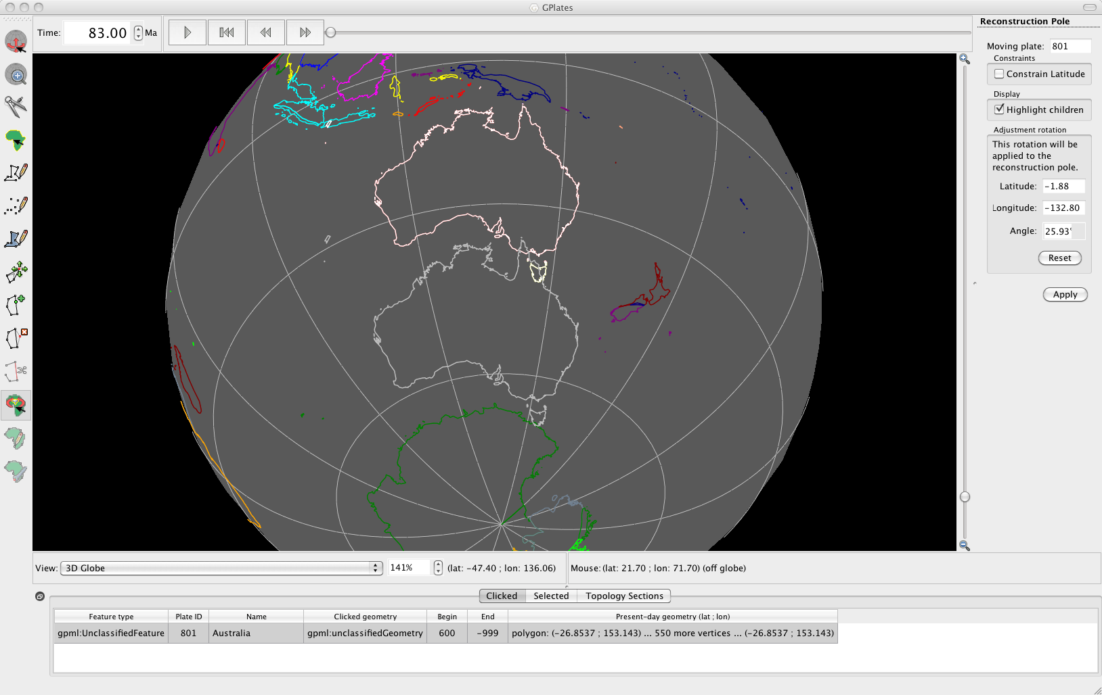

**Figure 4.** Australia has been dragged southward at 83 Ma to line up with Antarctica.

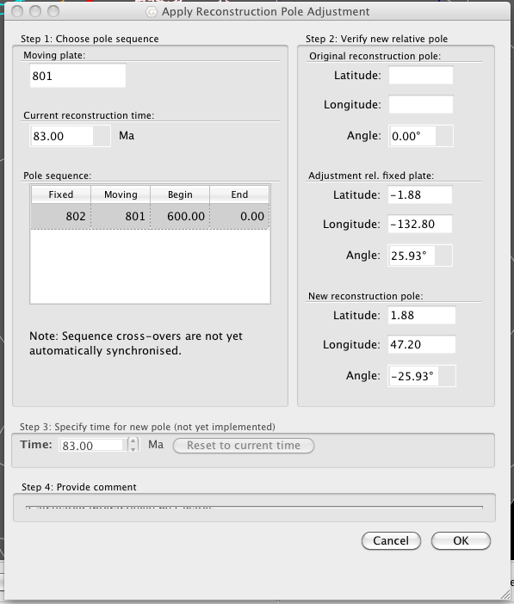

**Figure 5.** Apply Reconstruction Pole Adjustment window, where you can review the details of your rotation implementation.

1. In this window you can verify the new relative pole and details (Figure 5). Click OK, this will implement your rotation.

You will notice that Australia is now positioned adjacent to Antarctica at 83 Ma (Figure 6).

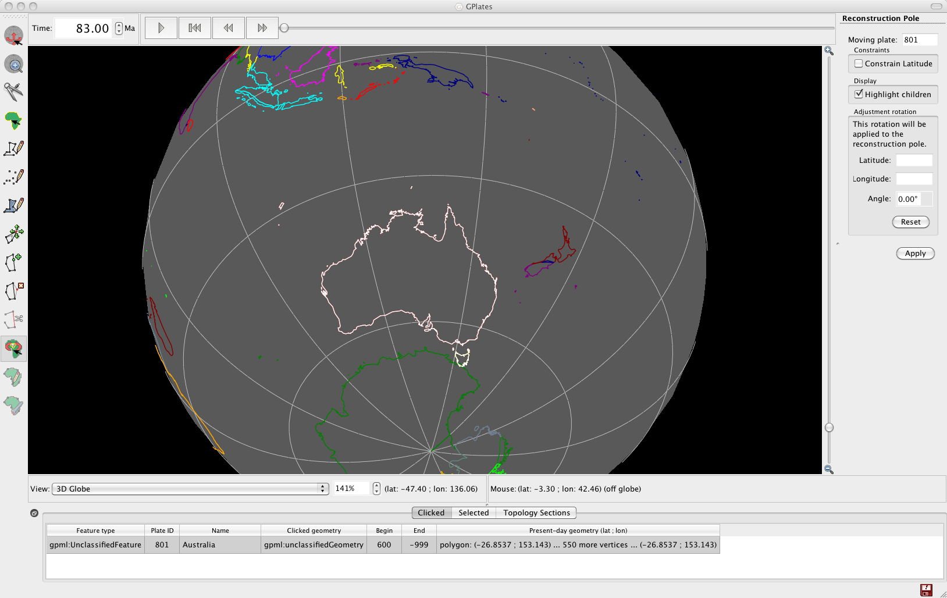

**Figure 6.** Australia is now positioned adjacent to Antarctica at 83 Ma. It is south of it’s

1. Now you need to save your rotation file. File > Manage Feature Collections > save a copy of the rotation file with a new name (this is so you can compare it to the old rotation file) > now load this new rotation file by clicking Open File and navigating to the directory where it is saved > Open.
2. Use the Animation slider to reconstruct from 83 Ma to the present. You will see Australia move in a northward direction relative to Antarctica!
3. However there is one more thing we need to do. If you jump to 600 Ma for example and animate back to 0 ma, you will notice that Australia starts in its present day coordinates, moves southward to its 83 Ma position and then moves northwards again. This is because the location of Australia at 600 Ma is the same as present-day in our rotation file (Figure 7). We need to alter the rotation file so that there are not rotations between 600 Ma and 83 Ma.

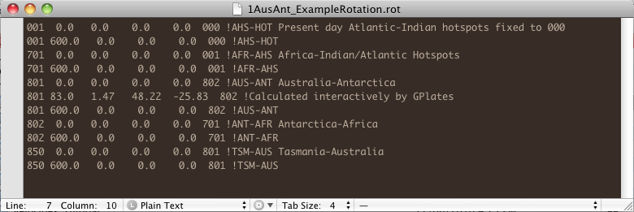

Figure 7. A rotation has been added for Australia at 83 Ma. However notice that the latitude and longitude of Australia at 600 Ma is the same as present-day.

1. Open the new rotation file in a text editor. And make the 600 Ma rotation data (lat., long., rotation angle) for Plate ID 801 the same as the 83 Ma rotation (ie duplicate the data) (Figure 8). This will result in no rotation between Australia and Antarctica until the period 83 Ma – 0 Ma.

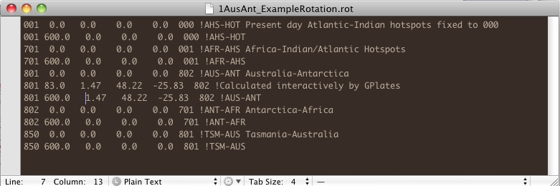

**Figure 8.** Modified rotation file, note that the 600 Ma and 83 Ma rotations for Plate ID 801 are the same.

1. Load your modified rotation file into GPlates and animate forward in time from say 150 Ma. You will notice that Australia stays attached to Antarctica until 83 Ma.

**EXCERISE 2: Modifying an Existing Rotation**

In this second exercise we will learn how to modify an existing rotation file. Keeping with the theme of Australia and Antarctica we will implement a new rotation for Australia at 83 Ma. Whittaker et al. (2007) proposed that 83 Ma Australia was located further eastwards with respect to Antarctica than previously thought (e.g. Tikku and Cande, 1999). They suggest that from ~83 Ma to 50 Ma Australia moved northwest relative to a fixed Antarctica, before then commencing northward motion between 50 Ma and the present. The timing of their proposed change in plate motion at ~50 Ma coincides with the Hawaiian-Emperor bend and subduction of the Izanagi-Pacfici ridge.

1. Eject all existing rotation files from GPlates. File > Manage Feature Collections > click the eject symbol:::Tutorial_ScreenShots:eject.tiff corresponding to all loaded rotation files. Keep the Manage Feature Collections window open.
2. Open File > select the rotation file for this exercise **Global\_EarthByte\_GPlates\_Rotation\_AusAnt\_Example.rot** > Open

The rotation file we have just loaded is significantly more complicated than that of the last exercise. Reconstruct the globe back through time and you will see that all the plates move. If you open this rotation file in a text editor you can see how much longer and more detailed it is compared to the last exercise.

1. Use the Time Controls to jump to 83 Ma.

We will use the fracture zones to help us constrain the position of Australia 83 Ma.

1. File > Manage Feature Collections > Open File > select AusAnt\_FZs.gpml from the data bundle > Open

Following Whittaker et al. (2007) we will align the Antarctic fracture zone with the most westerly Australian fracture zone, whereby shifting Australia east relative to a fixed Antarctica.

1. Use the Choose Feature button :::Tutorial_ScreenShots:ChooseFeature.tiff to select Australia > click Modify Reconstruction Pole Screen shot 2010-01-28 at 11 > drag Australia eastward so that the Antarctic fracture zone and the western Australian fracture zones are connected (Figure 9) > click Apply (right of globe) > you can then click OK in the Apply Reconstruction Pole Adjustment window once you have reviewed the details of your new reconstruction and are satisfied.

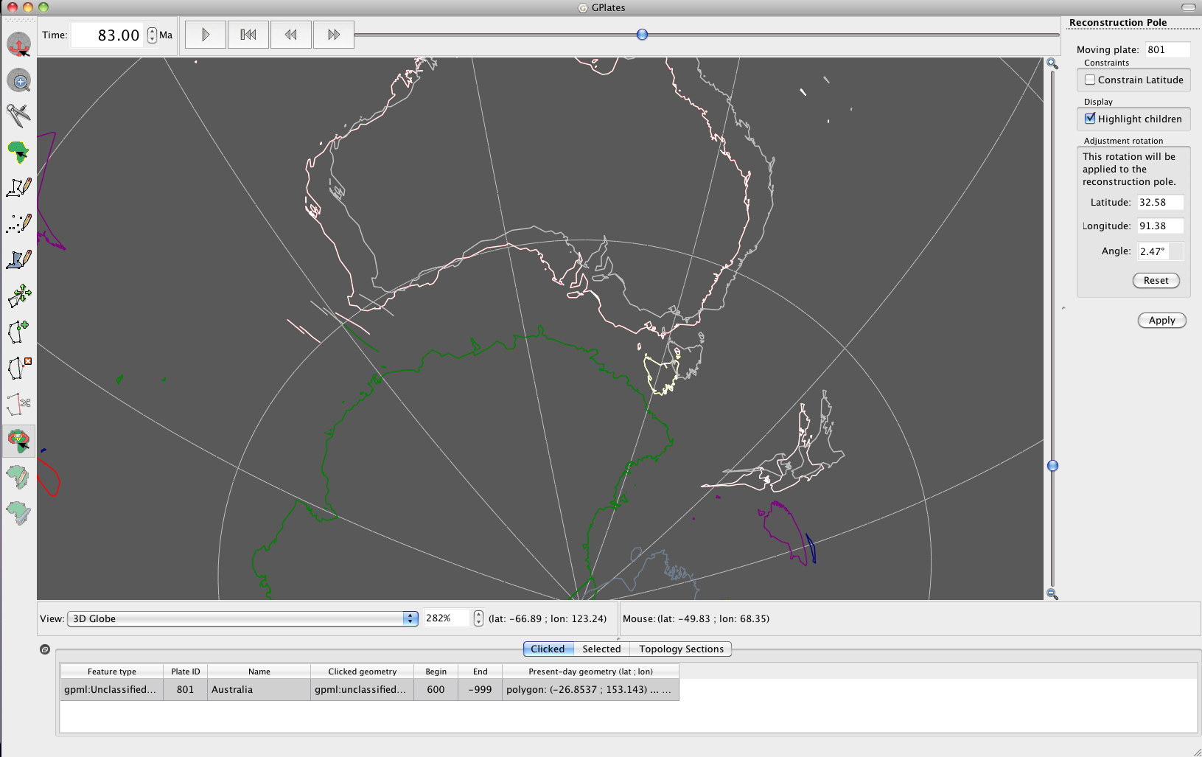

**Figure 9.** Australia shifted east using the Modify Reconstruction Pole tool.

When you return to the globe you will notice that Australia is located further east than when you started (Figure 10). We now need to save this data.

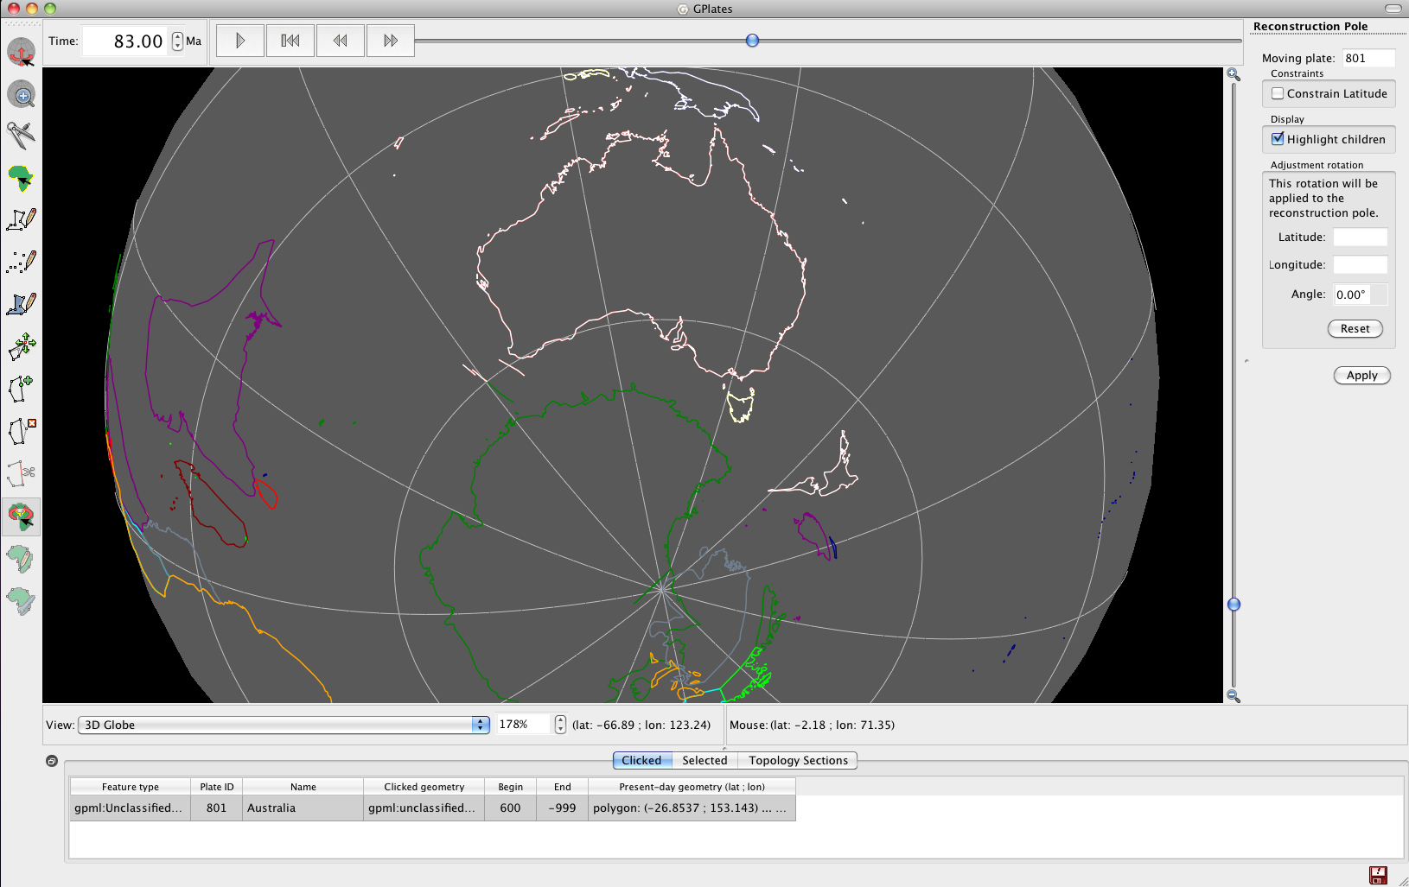

**Figure 10.** Australia shifted further east 83 Ma.

1. File > Manage Feature Collections > save your Global\_EarthByte\_GPlates\_Rotations\_AusAnt\_Example.rot file with a new name:::Tutorial_ScreenShots:SaveAs.tiff so that you preserve the old rotation file.

Now use the Time controls to watch Australia’s motion from 83 Ma to present-day and you will see that there is northwest motion of Australia relative to a fixed Antarctica between 83 Ma and ~50 Ma. Then Australia commences northward motion.

1. Open your modified rotation file and the original rotation file using a text editor and scroll down to the entries for Plate ID 801, compare the two rotation files, you will see that they have different entries now for 83 Ma (Figure 11).

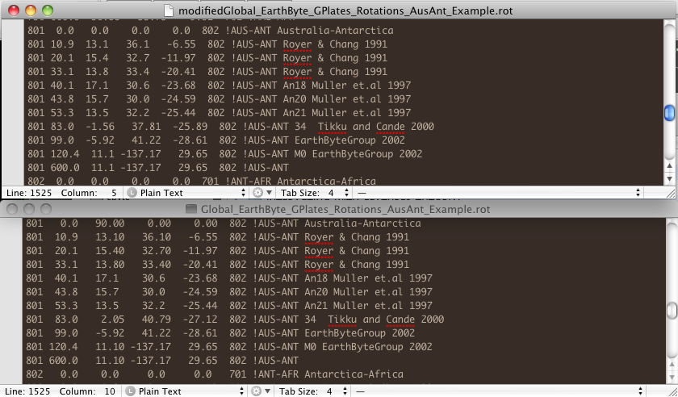

**Figure 11.** New (top) and old (bottom) rotation files showing entries for Plate ID 801. Entries for 83 Ma have changed.

Note: to better appreciate the change in motion of Australia relative to a fixed Antarctica you can specify Antarctica as the ‘anchored plate’ rather than the spin axis (default). Reconstruction > Specify Anchored Plate ID > enter 802. Now when you reconstruct the globe you can really notice that Australia moves in a northwest direction between 83 Ma and ~50 Ma.

**Things to consider:**

The cursor provides longitude and latitude locations to help with re-orienting. This is particularly useful when trying to replicate work from other literature.

Check the existing rotation file for the time increments for the plates. By reconstructing at these times will avoid jumps between two time steps. For example if the existing rotation file has rotations at 10 Ma and 20 Ma, by creating a new rotation at 16 Ma will only change the rotation between 10 Ma and 16 Ma. Between 16 Ma and 20 Ma the plate may jump erratically according to the old pole of rotation, unless you change it or an older timestep.

**ADDITIONAL EXCERCISE: Rotation of Borneo (Introducing how to reverse engineer rotations from images)**

In this final exercise we will move further afield to Borneo, Southeast Asia. The rotational history of Borneo (Kalimantan) is a contentious issue in the literature. Hall (2002) (Figure12), for example, impose a 45° counter-clockwise rotation of Borneo from 26 Ma to 10 Ma, whereas Lee and Lawver (1995) prefer no rotation of this block, with only a small latitudinal change. Another extreme is Replumaz and Tapponier (2003) (Figure 13) who favour a large clockwise rotation of Borneo, which appears to be incompatible with paleomagnetic data. However, the lack of large strike-slip faults around Borneo, which would be expected under significant rotation, suggest that Borneo experienced little rotation in the Miocene. Nevertheless this remains a debated topic.

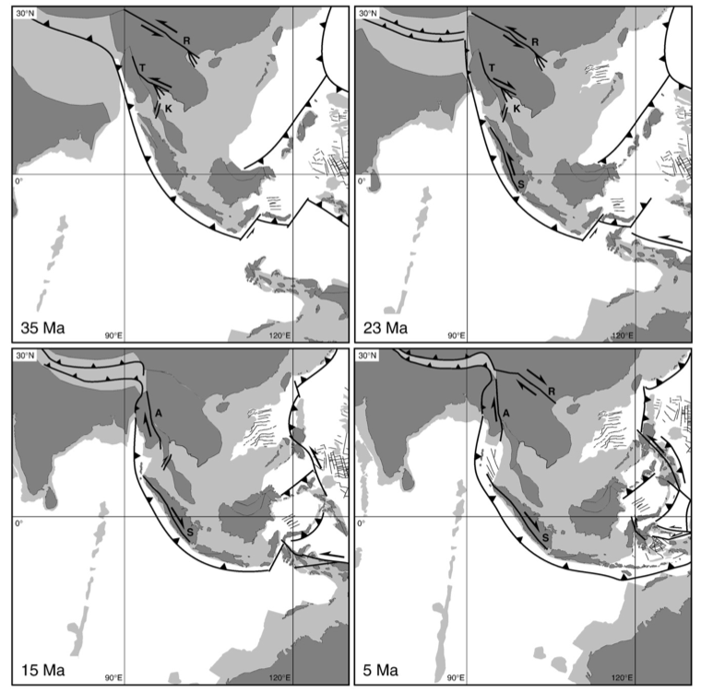

**Figure 12.** Reconstructions of the Sundaland region at 35Ma, 23Ma, 15Ma and 5Ma from Hall (2002). Notice the large anti-clockwise rotation of Borneo (red arrow).

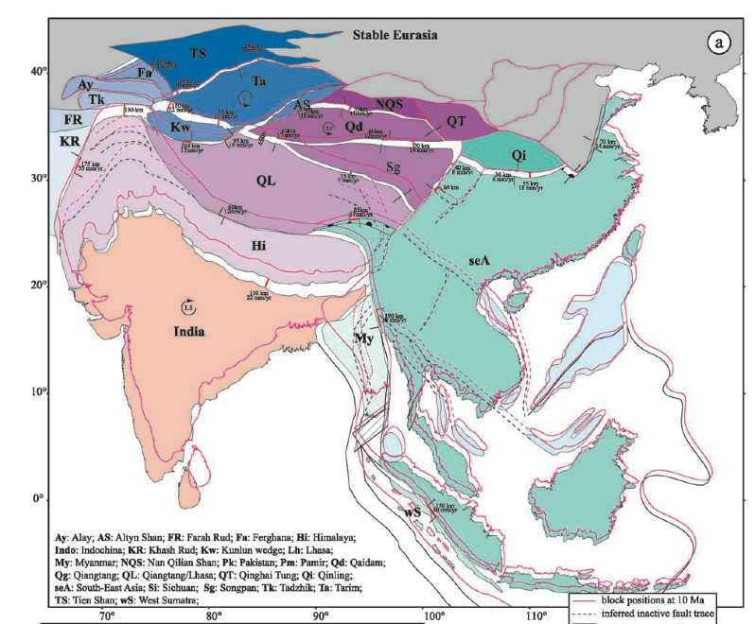

**Figure 13:** Replumaz and Tapponnier (2003) reconstructions of SE Asia between 10 Ma and 15 Ma.

There are a couple of approaches to reconstruct a rotation as derived from an image.

1. One way is to best discern the latitudinal and longitudinal locations of the feature manually, for example, by selecting a distinguishing part of the tectonic shape on the image (e.g. a peninsula) that is also replicated in the coastline file. The rotation should be manually changed in GPlates (See Exercise 1) until the correct coordinates and orientation are achieved. Remember to reconstruct the rotation at the correct time.
2. The second way is to load the image as a raster in GPlates (See Importing Rasters Tutorial), and reconstruct the rotation with the image as an underlying guide.
3. A third way is if you are provided with the three rotation pole values for a particular plate at a particular time period, with the conjugate plate specified. With this information you can manually enter it into the rotation file.

Method:

1. Rotate the window to SE Asia and select Borneo.
2. Select the relevant reconstruction time.
3. Rotate Borneo, using the skills you have developed in the previous exercise, to the desired location and orientation as determined by method of reconstruction e.g. raster loading or manual adjustment.
4. Once the feature attains the desired position and orientation, clicking Apply will transfer these changes to the rotation file.
5. To compare models you need to save the different reconstructions to different rotation files.

**References**

Hall, R. 2002. Cenozoic geological and plate tectonic evolution of SE Asia and the SW Pacific: computer-based reconstructions, models and animations. *Journal of Asian Earth Sciences*, 20; 353 - 431.

Lee, T.Y., and Lawver, L.A. 1995. Cenozoic plate reconstructions of Southeast Asia. *Tectonophysics.* 251; 85 - 138.

Replumaz, A. and Tapponnier, P. 2003. Reconstruction of the deformed collision zone between India and Asia by backward motion of lithospheric blocks. *Journal of Geophysical Research.* 108; 2285.

Tikku, A. A., and S. C. Cande. 1999. The oldest magnetic anomalies in the Australian-Antarctic Basin: Are they isochrons? *Journal of Geophysical Research*. 104(B1); 661–677.

Whittaker, J.M., Müller, R.D., Leitchenkov, G., Stagg, H., Sdrolias, M., Gaina, C., and Goncharov, A. 2007. Major Australian- Antarctic Plate Reorganisation at Hawaiian-Emperor Bend Time. *Science.* 318; 83 - 86.