***GPlates* Tutorial**

**Velocity Fields**

Sabin Zahirovic1, Kara J. Matthews1 & R. Dietmar Müller1

1EarthByte Research Group, School of Geosciences, University of Sydney, Australia



[**www.gplates.org**](http://www.gplates.org)

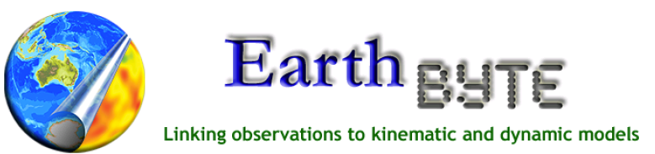

**Aim**

This tutorial is designed to teach the user how to generate velocity fields for topologically closed polygons. These closed and dynamic polygons must be created in GPlates first. See the ‘Topology Tools’ section in the user documentation for more information on creating closed dynamic polygons.

Velocity output can be used as plate kinematic input for geodynamic modelling codes*.* GPlates is capable of directly generating time-dependant velocity fields for the mantle convection modelling code *CitcomS*. GPlates can also be linked to the *TERRA* mantle convection code. Importantly, users can extract the required data from the velocity output and make it compatible with their own particular modelling code.

All the required files for this tutorial, including the dynamically closing plate polygons, are contained in the accompanying data bundle.

**Required data:**

* Velocity Tutorial Data Bundle

**Background**

**What is a mesh? What is it used for?**

A mesh is an equally spaced grid of coordinate points. The distance between the points is equal on a spherical surface such as the Earth[1]. The use of a mesh is critical in linking plate kinematics and geodynamic models. For example, *CitcomS* uses a static mesh that measures the velocity of the tectonic plates through time at each node.

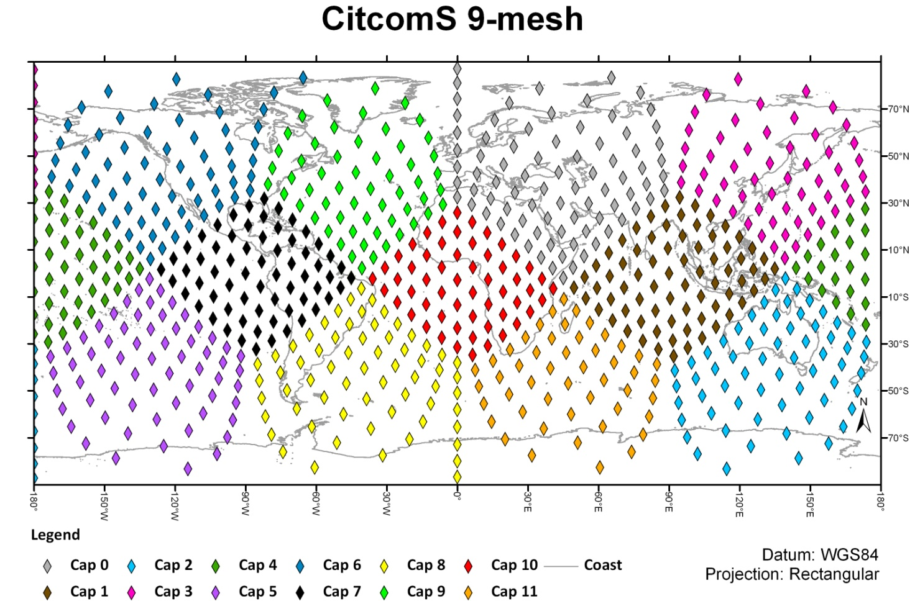

**Figure 1.** CitcomS 9-mesh global cap and node distribution

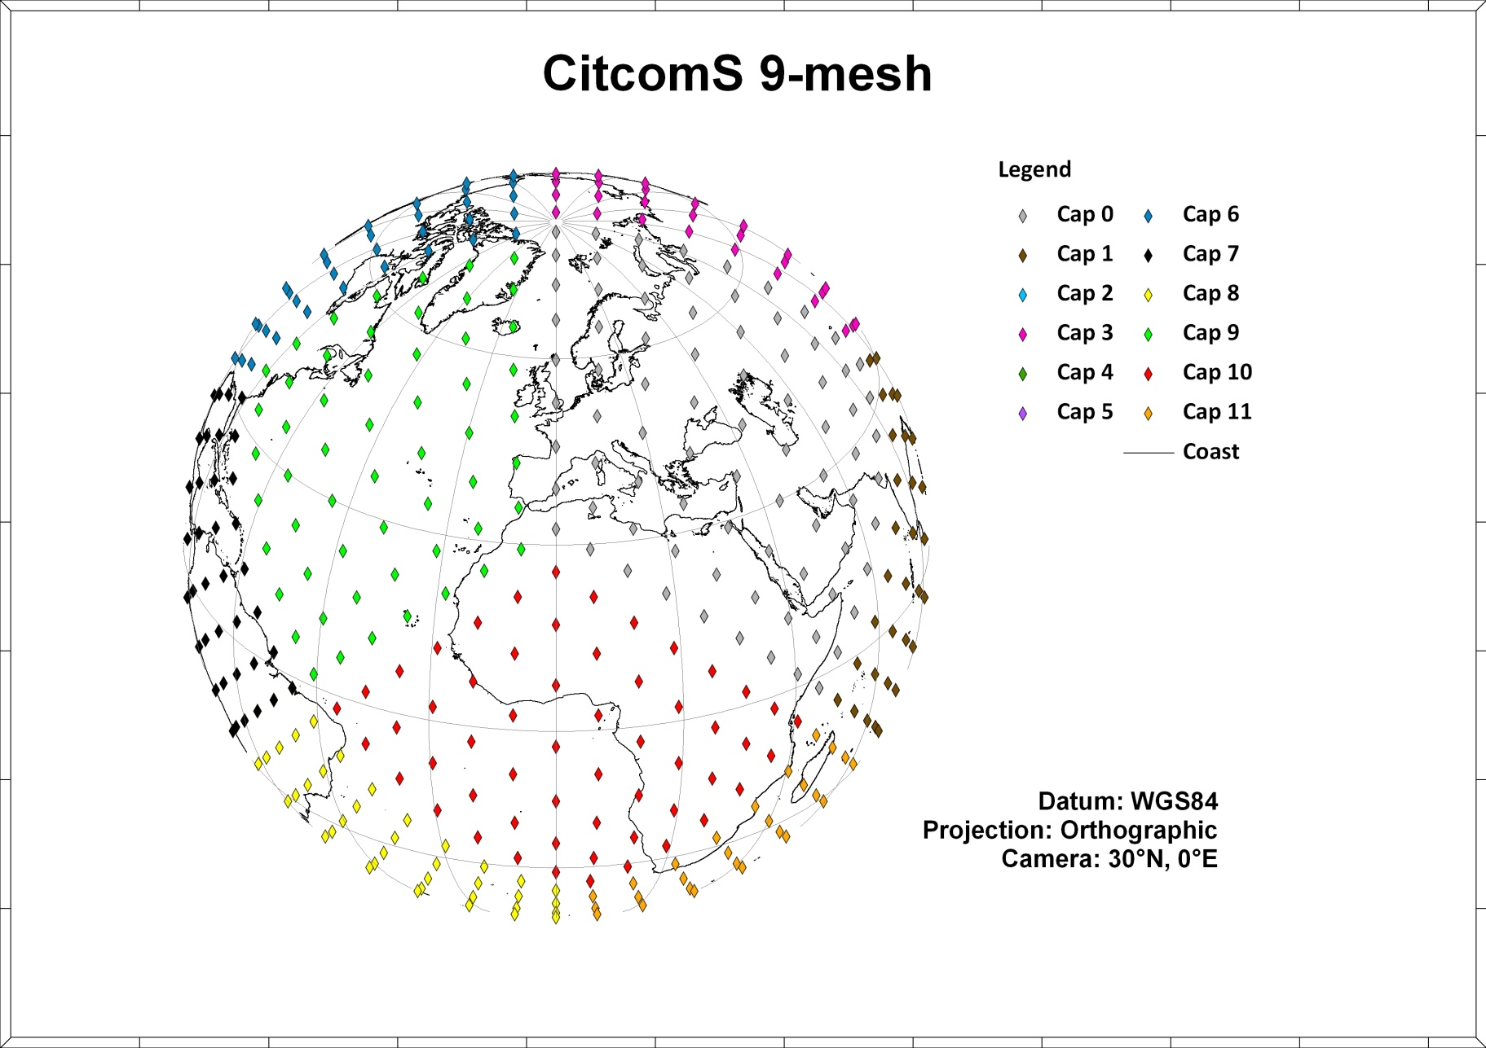

**Figure 2.** CitcomS 9-mesh node distribution

**CitcomS Mesh Specifications[2]**

CitcomS meshes can be either regional or global. A global mesh is composed of 12 diamond-shaped ‘caps’ – numbered from 0 to 11. The density of the mesh nodes can be adjusted. The global distribution of ‘caps’ can be seen in Figure 1. The rectangular projection does not preserve the uniform distance between the nodes, whereas an orthographic projection is a better representation of the inter-nodal distance (Figure 2).

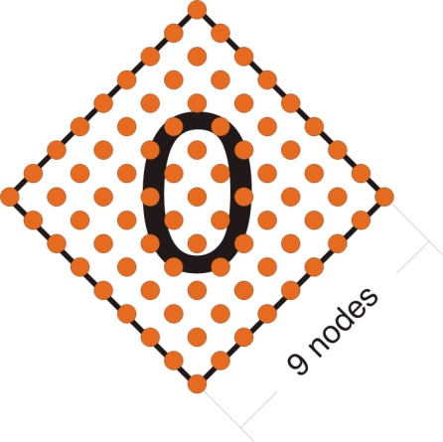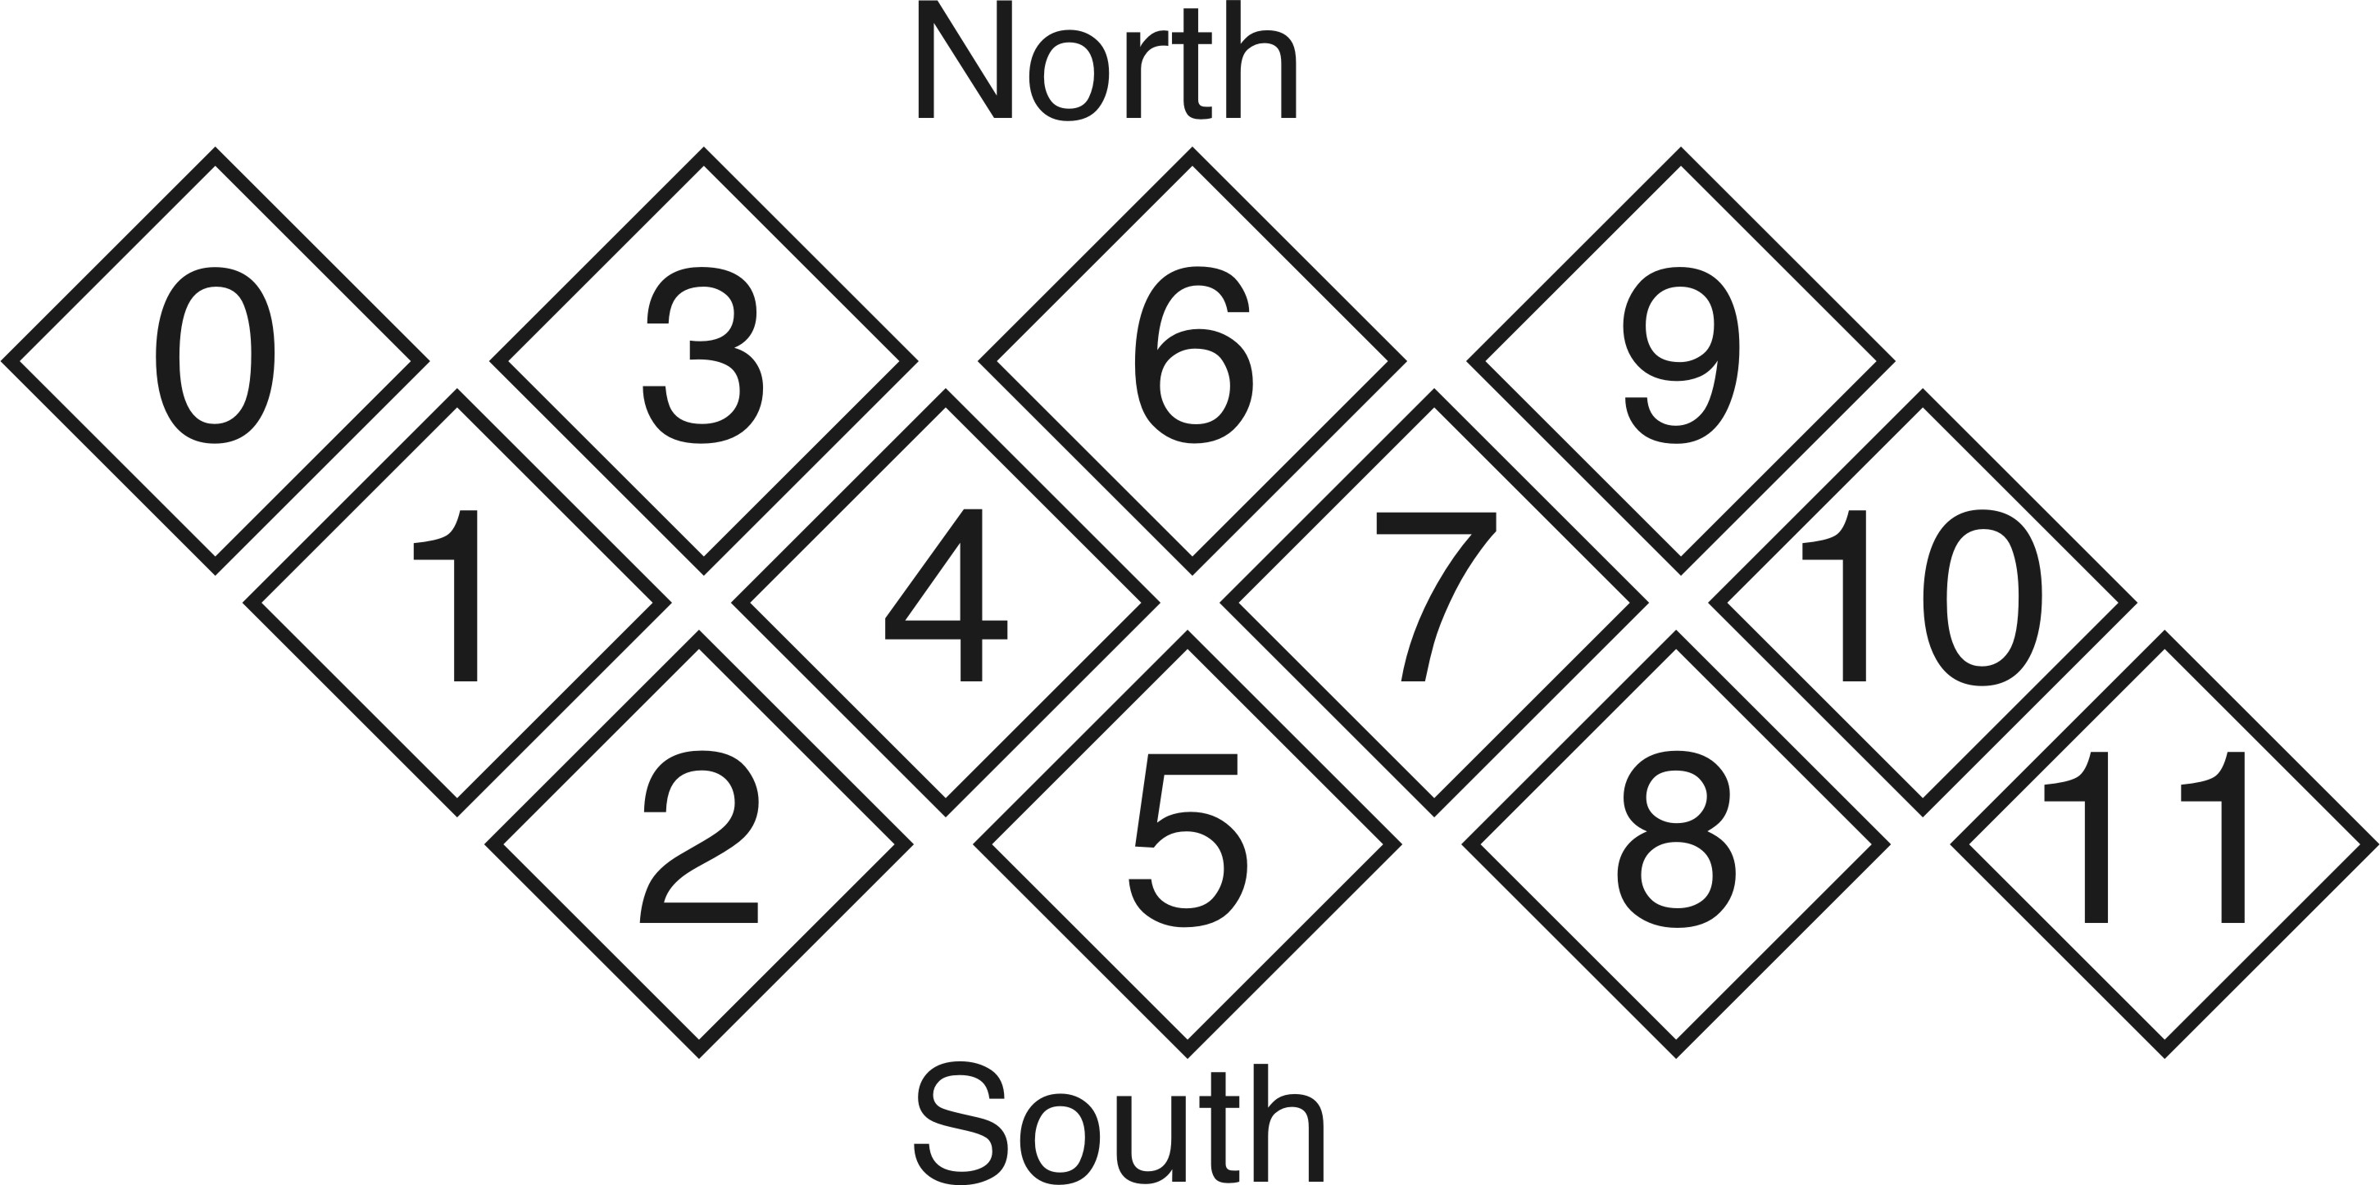

**Figure 3.** CitcomS Mesh – Cap 0 with 9 X 9 nodes (Left), and Caps 0 to 11 global distribution (Right)

In Exercise 2 we will make each cap comprise 9 X 9 nodes (Figure 3. This is a reasonably coarse mesh, especially for mantle convection modelling purposes. Mesh caps are composed of *n2* nodes (n being the number of points along each side of the cap), and so processing the velocity of denser grids increases proportionally to the square of the node numbers along each cap side (See Figure 4).

|  |  |  |  |
| --- | --- | --- | --- |
| **Nodes per cap side** | **Nodes in One Cap** | **Total number of Mesh nodes** | **Increase in global density from 9 X 9 cap** |
| 9 | 81 | 972 | 0 % |
| 10 | 100 | 1,200 | 23 % |
| 11 | 121 | 1,452 | 50 % |
| 12 | 144 | 1,728 | 77 % |
| … | … | … | … |
| 50 | 2,500 | 30,000 | 2990 % |

**Figure 4.** The increase in mesh density follows the square law, meaning that computation time of velocities increases significantly with increasing mesh density

**EXERCISE 1 - Rotations and Dynamically Closing Polygons**GPlates uses a rotation file to reconstruct geometries through time. The geometry features are a set of intersecting lines, each assigned a Plate ID and thus move according to the information in the rotation file. These geometries can be used to create a set of dynamically-closed plate polygons. The result of this is that the surface of the Earth is split into a discrete number of tectonic plates to cover the temporal span of the plate kinematic model. The velocity of each plate through time will be tracked in GPlates by the mesh files we will create in the next exercise.   
  
At each time interval in GPlates the mesh nodes are assigned Plate IDs according to the plate polygon on which they are located. These velocities can be used as boundary conditions for mantle convection models, including *CitcomS* and *TERRA*. In this way GPlates provides a link between plate kinematics and mantle dynamic processes.   
  
In order to generate and export plate velocities through time, GPlates expects a rotation file and a file of dynamically-closing plate polygons, along with our mesh files. The sample data contains all the necessary input files. For more information please visit the GPlates User Documentation online[3].

1. Click File 🡪 Manage Feature Collections
2. Click ‘Open File’ and navigate to the folder containing the geometry and rotation files. We will select the following geometry (GPML) and rotation (ROT) files:

- Caltech_Global_20100713.gpml  
 - Caltech_Global_20100713.rot

The boundaries and the associated polygons are now displayed. In this model absolute plate rotations are a combination of a moving hotspot reference frame (O’Neill et al., 2005) for 0-100 Ma and a fixed hotspot ref frame from 100-140 Ma (Müller et al., 1993) in the form of topological plate boundaries (Gurnis et al., in revision). GPlates automatically displays the velocity vectors based on the dynamically closing polygon and rotation files (Figure 7). That means your data MUST contain topological polygons created in GPlates with assigned Plate IDs, as it reads the rotation file and calculates velocity vectors on the fly for each mesh node.

The latest GPML and ROT files can also be downloaded from the following website: http://www.gps.caltech.edu/~gurnis/GPlates/gplates.html. Note: filenames may differ.   
  
You may want to load up a coastline file to help identify the regions of the world.

**EXERCISE 2 - Generating a Mesh File**

GPlates currently supports the generation of global mesh files. These mesh files consist of 12 caps that cover the globe (see CitcomS Mesh Specifications above). Each point in the mesh is a “sampling” location of velocity, for the tectonic plate in which it is located. This is a CitcomS standard. Ultimately the following steps will allow you to create velocity fields as input for mantle convection modelling in CitcomS. Information can be extracted for other purposes, CitcomS modelling is merely the example used here.

The density of the mesh points can vary, and is dependent on your application. For the purpose of this tutorial, we will use a coarse mesh of 9 X 9 nodes.

1. Open GPlates
2. Reconstruction 🡪 Generate Mesh Cap… (Figure 5)

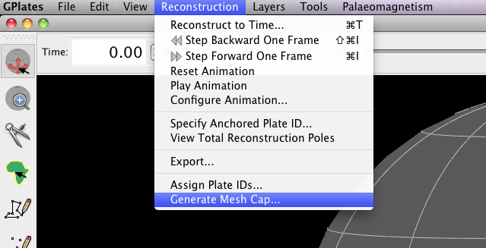

**Figure 5.** How to open the Generate Mesh Caps window from the main menu.

1. Our mesh file will have a 9 X 9 nodes resolution, so enter 9 into the ‘nodeX’ box (9 will automatically be entered in the nodeY box) (Figure 6).

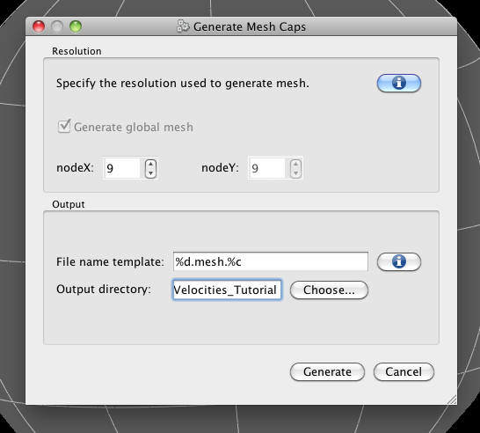

**Figure 6.** The Generate Mesh Caps window enables you to define the resolution and saving destination of your mesh file.

1. Enter the destination where you would like the save the mesh files (it is suggested that you make a directory called ‘Velocity_Tutorial’) 🡪 Generate.

12 mesh files with 9 X 9 nodes have been saved into the directory you specified. These files have also been loaded into GPlates. The files are named 9.mesh.X.gpml, where X is the cap number, ranging from 0-11. You can see that they are loaded by opening the Manage Feature Collections window (File 🡪 Manage Feature Collections).

In Figure 7 (below), the red arrows correspond to the velocity vectors of the Indo-Australian Plate. The velocity vectors indicate both the magnitude and direction of motion. The plate velocity display is quite useful to assess shortcomings or bugs in plate tectonic models. Reconstruct and animate the globe through time and inspect visually how absolute plate velocities change through time.

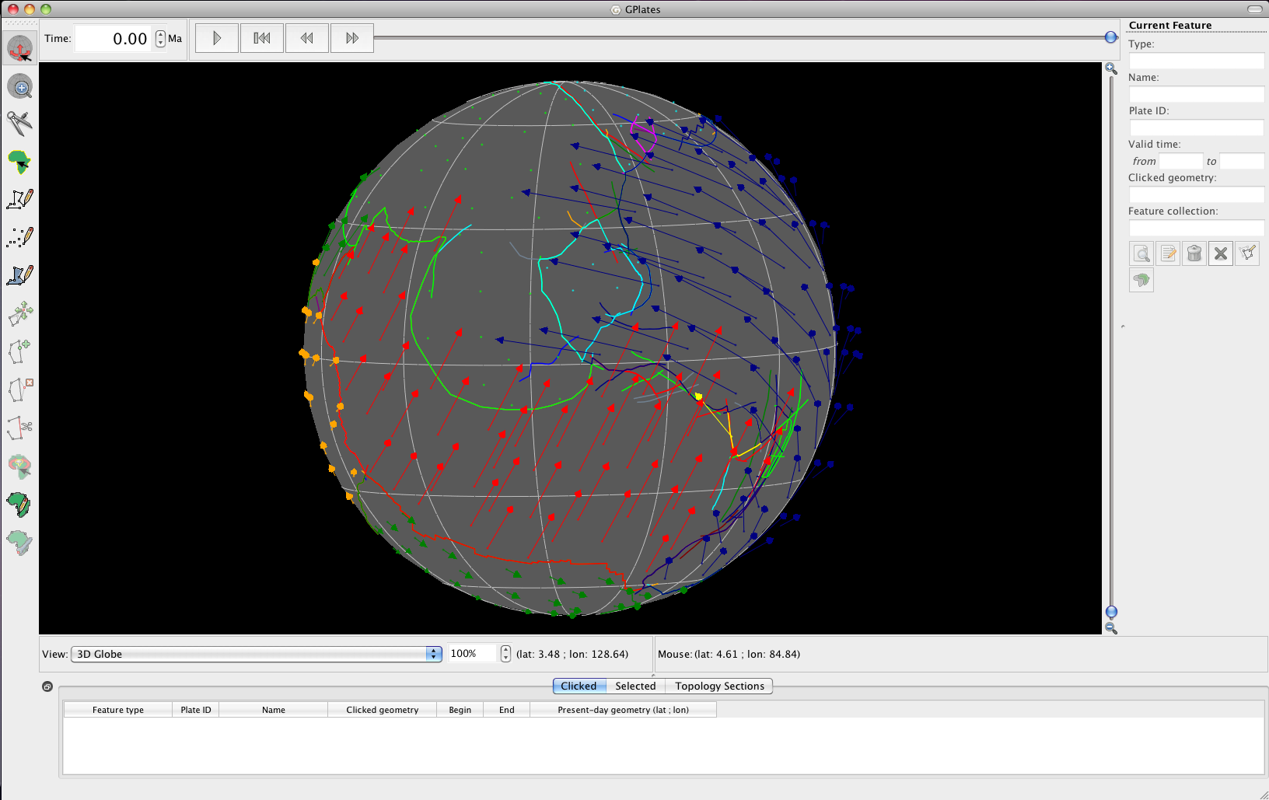

**Figure 7.** The GPlates globe displaying polygon outlines and velocity vectors.

**EXERCISE 3 – Exporting Velocities**

GPlates can export animations in a number of formats. For the purposes of creating velocity fields, only one is of interest to us. The output files generated will be in GPML format.

Note: *CitcomS* requires simple ASCII text files of the velocity fields as input, therefore if you plan to use CitcomS you will need to convert the GPML files to ASCII.

1. Reconstruction 🡪 Export… (Figure 8)

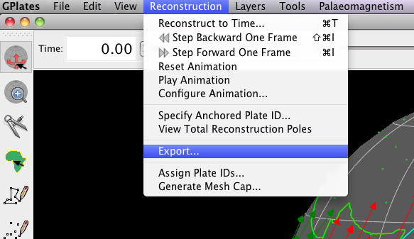

**Figure 8.** Navigating the main menu to open the Export Animation window.

1. We will export velocities from 10 Ma to present-day, with an increment of 1 Myr per frame. Therefore, all you need to change in the ‘Range’ box (top) is the ‘Animate from’ time to 10.00 (Figure 9).

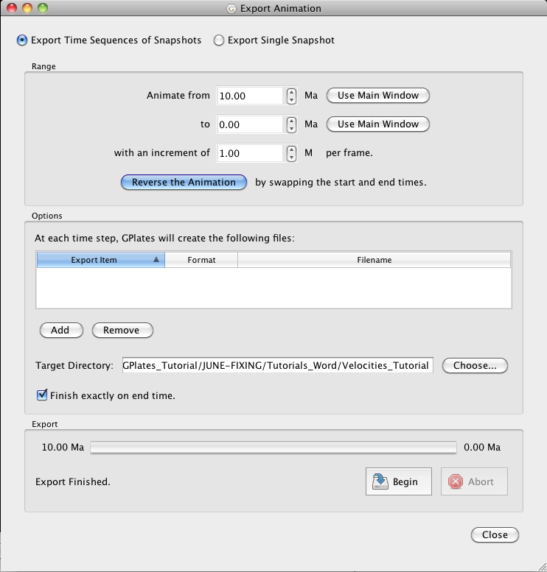

**Figure 9.** The Export Animation window enables you to set the temporal parameters of your export. See top section entitled ‘Range’.

1. We must now specify what files we wish GPlates to generate 🡪 click Add.
2. In the ‘Add Export’ window select Colat/lon Mesh Velocities and then the GPML format (Figure 10) 🡪 Add 🡪 Close (close the Add Export window as we do not wish to generate any additional files.

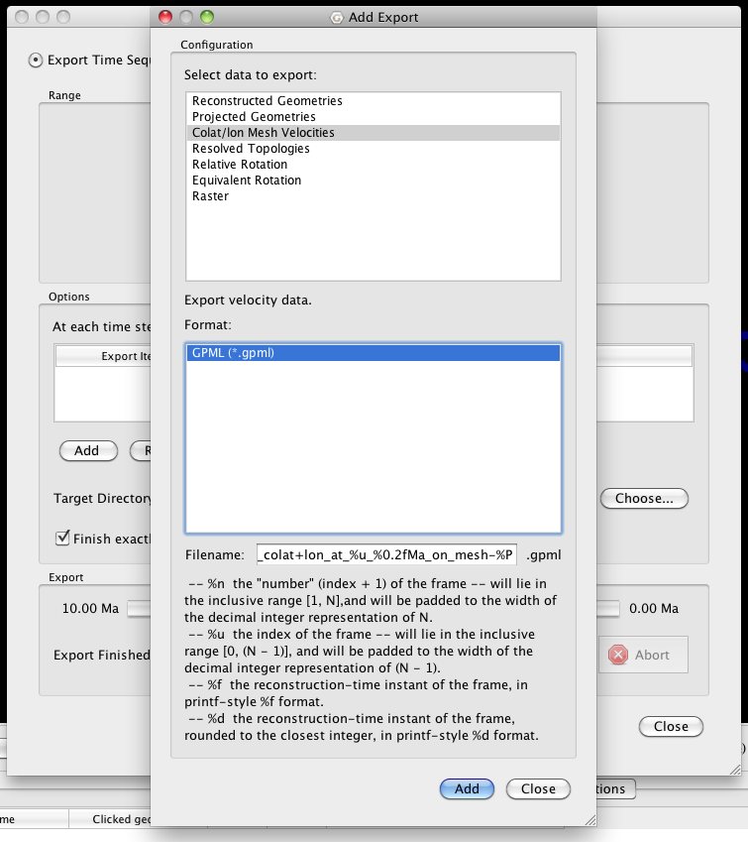

**Figure 10.** The Add Export window enables you to choose which files GPlates will generate for your time interval.

1. Choose the target directory where the output will be created and then click Begin. The files will now be generated. To save time we have only selected 10 Myr.

The velocity files are now saved in your selected target directory. A velocity file is generated for very cap, every 1 Myr (as this was the interval chosen).

**References**

Müller, R.D., Royer, J.-Y. and Lawver, L.A., 1993. Revised plate motions relative to the hotspots from combined Atlantic and Indian Ocean hotspot tracks. Geology, 16: 275-278.

O’Neill, C., Müller, R.D. and Steinberger, B., 2005. On the uncertainties in hotspot reconstructions, and the significance of moving hotspot reference frames. Geochemistry, Geophysics, Geosystems, 6, Q04003, doi:10.1029/2004GC000784, 1-35.

Michael Gurnis, Mark Turner, Lydia DiCaprio, Sonja Spasojevic, R. Dietmar Müller, James Boyden, Maria Seton, Vlad Constantin Manea, and Dan J. Bower and Sabin Zahirovic, in revision, Global Plate Reconstructions with Continuously Closing Plates, Geochemistry, Geophysics, Geosystems.

1. *In fact the shape of Earth is not spherical, but rather an ellipsoid. However, the deviation from sphere to ellipsoid is small – and for the purpose of modelling, the sphere is the simplest case. Modelling requires millions of computations, which would be much slower if the actual spheroid shape of the Earth was implemented. As a result, the sphere is the closest estimate requiring simpler computations.* 
2. *The CitcomS manual is an extensive and useful document containing additional information. It is available from the Computational Infrastructure for Geodynamics website (*[*http://www.geodynamics.org/cig/software/packages/mc/citcoms/*](http://www.geodynamics.org/cig/software/packages/mc/citcoms/)*)* 
3. *GPlates User Documentation located at http://www.gplates.org/user-manual/*