Geophysical Research Letters
Supporting Information for
Sorting normal and anomalous mantle from the complex relationship between abyssal hill roughness and spreading rates
John A. Goff
Institute for Geophysics, Jackson School of Geosciences, University of Texas at Austin

Contents of this file

Text S1
Figure S1

Additional Supporting Information (Files uploaded separately)

Captions for Datasets S1

Introduction
This supplementary information contains two parts:
- An overview description of the methodology used by Goff (2010) to formulate predicted abyssal hill RMS heights based on the small-scale roughness properties of the satellite gravity data, and
- A digital version of the latest update to the global prediction abyssal hill RMS heights.

Text S1. Updated Abyssal RMS Prediction
The methodology developed by Goff (2010) to estimate abyssal hill RMS heights based on small-scale gravity roughness, updated to include the most recent gravity compilations, involves three overarching steps that are summarized below:

1. Masking and filtering the gravity field. A mask is used to remove from consideration large features, such as seamounts and MORs, that can be easily distinguished by eye. Fracture zones and other off-axis discontinuities are not treated in this way because they are too closely integrated with abyssal hills. Rather, a directional filter is applied which finds the minimum variance of a polynomial fit residual along profiles across a range of azimuths, and applies the fit and residual as a low-pass and high-pass filter product, respectively, at that point. The minimum residual variance azimuth will align with orientations of strong linear features such as fracture zones.

2. Computation of excess gravity variance. The high-pass filtered product is used to compute small-scale gravity variance across 1° by 1° regions, with a correction applied to account for variance reduction associated with the effects of the directional filter. A predicted gravity noise variance is then subtracted to compute excess variance; i.e., the amount of small-scale gravity variance that can be attributed to topographic effects. Goff (2010) estimated gravity noise variance by empirically correlating satellite altimeter noise (Goff, 2009) to small-scale gravity variance in “candidate” regions that appear visually to be devoid of topographic influence (Fig. S1). Altimeter noise, which can be estimated through a covariance analysis, exhibits a global pattern that is strongly influenced by two environmental parameters: significant wave heights and precipitation bands (Goff, 2009). Goff (2010) surmised that, given that many of the candidate regions were not perfectly flat topographically, the relationship between altimeter and gravity noise would be best represented by the bottom boundary of this population. For the Smith and Sandwell (1997) gravity Version 16.1 used in that analysis, Goff (2010) found that the bottom boundary was well fit by a linear trend (Figure S1). A reanalysis of this relationship using gravity Version 28.1 (Sandwell et al., 2014), for the same candidate regions, is shown in Fig. 1. The comparison illustrates the significant reduction in noise variance afforded by the later version. For example, the lowest gravity variance observed in Version 16.1 is approximately 3 mGal2, whereas for Version 28.1 it is less than 1 mGal2. Instead of a linear trend, the base of the population is better represented by a quadratic trend (Figure S1). This functionality is utilized in the new estimation gravity noise variance for the determination of excess gravity variance.

3. Downward continue excess gravity variance. Transfer functions are formulated that define the relationship between abyssal hill RMS heights and gravity RMS heights. The relationship between seafloor topography and sea surface gravity is specified by the upward continuation equation (Smith; 1998), and depends on water depth and seafloor/seawater density contrast. Water depths are derived from the global bathymetry compilation (Sandwell et al.,2014). Basement/seawater densities are assumed to be 1770 kg/m3 (Smith, 1998), but seafloor/seawater densities will be modified by sediment cover. Goff (2010) formulated an “effective” density contrast based on the ratio between basement RMS heights and sediment thickness; this same method is utilized here, but using the more recent global thickness map of Straume et al. (2019). Transfer functions are then formulated by (a) generating a suite of synthetic abyssal hills over a range of RMS heights, and with length/width parameters appropriate to those values, (b) converting to gravity with the upward continuation equation over a range of water depths and sediment thicknesses, and then (c) computing the resulting gravity RMS heights. Estimation of abyssal hill RMS heights from small-scale gravity RMS heights is accomplished by inverting these transfer functions.

The resulting predicted abyssal hill RMS heights, derived from the global Version 28.1 gravity data, and interpolated across gaps < 4°, are shown in Figure 1 of the main text. The principal improvements over the earlier version (Goff, 2010) are concentrated in low-RMS regions, where the lower gravity noise estimates enabled better detection of topographic influence on the small-scale gravity RMS. Nevertheless, some areas, including the Reykjanes Ridge north and south of Iceland, still do not exhibit sufficient excess gravity variance to enable an RMS height prediction.

References
Goff, J.A. (2009). Statistical characterization of Geosat altimetry noise: Dependence on environmental parameters. Geochemistry, Geophysics and Geosystems, 10, doi:10.1029/2009GC002569.
Straume, E.O., Gaina, C., Medvedev, S., Hochmuth, K., Gohl, K., Whittaker, J.M., Abdul Fattah, R., Doornenbal, J.C., & Hopper, J.R. (2019). GlobSed: Updatedtotal sediment thickness in the world’s oceans. Geochemistry, Geophysics and Geosystems, 20, 1756-1772.

Figure S1

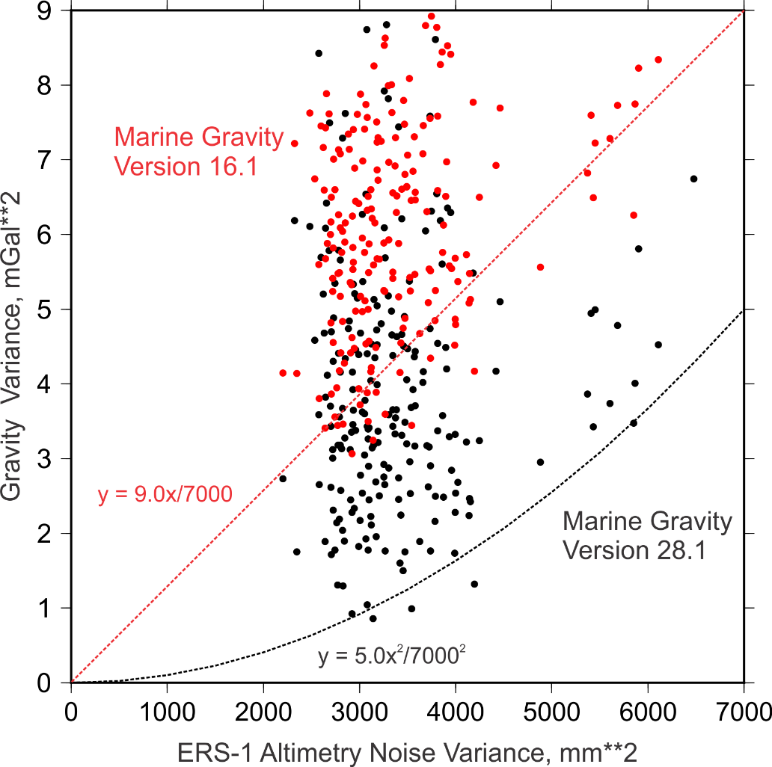

Small-scale gravity variance versus ERS-1 altimetry noise variance. Each dot represents a 2° by 2° area selected by Goff (2010) as candidate regions for establishing this relationship due to their likely low seafloor topographic expression. The small-scale gravity variance is calculated from marine gravity model Versions 16.1 (red dots; Smith and Sandwell, 1997) and 28.1 (black dots; Sandwell et al., 2014). ERS-1 altimetry noise variance is estimated globally from a covariance analysis by Goff (2009); these results express a clear spatial pattern of altimetry noise that is highly correlated to significant wave heights and precipitation intensity. Given that no region is entirely devoid of true gravity variability, Goff (2010) hypothesized that the lower bound of this population provides a good estimate of the gravity noise variance at any location given the known altimetry noise variance. For gravity model Version 16.1, this relationship was well represented by a linear trend. For Version 28.1, the evident gravity variance is significantly reduced, and the bottom boundary is better represented by a quadratic trend. Both trends are noted on the graph.

Data Set S1.

The updated global prediction of abyssal hill RMS heights (“abyssal_hill_rms_prediction_v2.0”) is provided here in the supplementary material. The grid is stored in a NetCDF file suitable for use in Generic Mapping Tools or other graphics and analysis applications.

